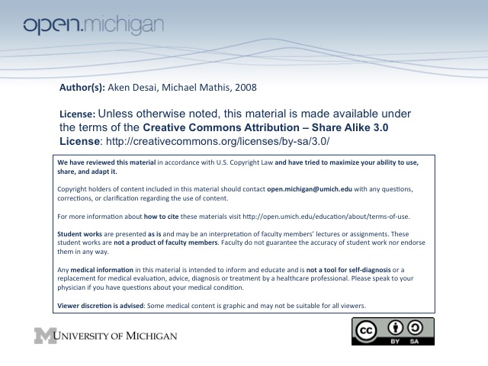
Substance Abuse/Addictions
Substance Abuse Epidemiology
- Alcohol Abuse – 14% lifetime prevalence
- Any other Drug Abuse (not smoking) – 6% lifetime prevalence
- Hospital Setting Alcoholism – 27% at UMHS
- Economics of Alcoholism – huge losses in productivity, also lost in legal system enforcement
- Mortality – 400,000/year smoking, 100,000/year alcohol, 20,000/year illicit drugs
- QUIZ: Widest illicit drug in use – marijuana
Substance Abuse Risk Factors
- Genetics – certain patients more predisposed to addiction; children of alcoholics 3x likely to be alcoholic
- QUIZ: Personality – antisocial personality (criminals) have very strong predisposition
- Rapid Action – the more rapidly-acting a drug is, the more addictive (e.g. smoking → 15 seconds)
- Gateway Availability – risk of other drug abuse increases if already abusing one (marijuana = gateway)
- Age – prevalence drops after 55, peak risk is 18-24
Drinking Risks
- Low Risk Drinking – 0-3-4-7-14 → 0/wk (preg/med/ill), 3/day (F), 4/day (M), 7/week (F), 14/week (M)
- General Guidelines – no more than 1 drink/hr, no drinking on empty stomach, BAC < 55 (speed limit)
High Risk Drug Use
- Prescription Risks – risk if using higher dose, if self-prescribed, or using for non-prescribed reasons
- Alcohol/Illicit Drug Abuse – increases risk of abusing prescription drugs
- Illicit Risks – illegal, no quality assurance, illegal because they are risky!
- QUIZ: Bipolar Disorder – has highest risk for substance abuse disorder (followed by schizophrenia)
Diagnosis & Treatment
- Do No Harm – not screening = doing harm!
- Abuse Disorder Categories: Substance abuse, substance dependence, physical dependence
  - Substance abuse – use drug despite social consequences or when potentially hazardous
  - Substance dependence – use drug despite know consequences, impaired control, tolerance
  - Physical dependence – separate from abuse/dependence categories, just means tolerance/withdrawal can occur → substance dependence has physical dependence
- Substance Dependence DSM Criteria – physical dependence, impaired control, life re-organized, cont.
  - Physical Dependence – build up both a tolerance to drug and experience withdrawal
  - QUIZ: Don’t need physical dependence – only need ¾ DSM criteria, thus D_{z} if 3 below true:
  - Impaired Control – more substance taken than intended, unable to cut down/control use
  - Life organized around drugs – takes up time, replaces work/leisure activities
  - Continued Use – despite knowing physical/psychological problems worsened by use
- Substance Abuse DSM Criteria – impaired work/social, physically hazardous use, legal:
  - Recurrent Failure – to fulfill obligations at work, school, home, b/c of drug
  - Physically Hazardous Use – continue to use drug even in physically hazardous situations
  - Legal Problems – recurrent substance-related legal problems
  - Social/Interpersonal Conflict – continued use despite social/interpersonal exacerbations
Alcoholism Screening
- Frequency – ask how many days a week do you drink (better than asking how much/how often)?
- Quantity – ask how many drinks you have on days you drink?
- Maximum – what is the most drinks you had in one day in the past month?
- CAGE Questions – cut down, annoyed, guilty, eyeopener → 2 yes = positive screen
  - Cut Down – do you ever feel you should cut down on your drinking?
  - Annoyed – have people ever annoyed you by criticizing how much you drink?
  - Guilt – have you ever felt guilty about how much you drink?
  - Eyeopener – have you ever had a drink first thing in the morning for steady nerves/hangover?
Alcoholism Treatment
- Abstain – 1/3 abstain completely from drinking after treatment
- Improvement – 1/3 improve to drinking less often after treatment
- No improvement – 1/3 don’t improve
- Physicians – as a group, can respond very well to alcoholism treatment
- Relapse – like any chronic illness, relapse risk high
Cross-Tolerance, Cross-Dependence
- Cross-Tolerance – if tolerance exists to drug A after repeated exposure, tolerance also for drug B at 1st use
- Cross-Dependence – if two cross-tolerant drugs can suppress withdrawal symptoms for the other
- Examples: GABA, DA, 5HT₂
  - Alcohol vs. BZDs – both target GABA receptor… don’t treat panic-disordered alcoholics w/ BZD
  - Amphetamine vs. Cocaine – both target dopamine receptor
  - LSD/Psilocybin – both target 5HT₂ receptor (serotonin)
QUIZ: Drug Mechanisms
- Amphetamine – increases dopamine → by increasing release and inhibiting re-uptake
- Cocaine – blocks reuptake of DA, 5HT, NE
- Caffeine – blocks adenosine receptors
- Cannabis – binds to cannabinoid receptors → has a specific receptor!
- Hallucinogens – 5-HT (serontonin) receptor agonist
- PCP – blocks NMDA (glutamate receptor)
- Anabolic Steroids – bind to intracellular androgen receptors
Amphetamines
- Amphetamine – increases dopamine → by increasing release and inhibiting re-uptake
  - vs. MDMA – “ecstasy”, not a stimulant (dopamine receptor), actually a hallucinogen (serotonin)
  - vs. Cocaine – same mechanism, but amphetamines last longer, and enable dopamine release
- Schedule II Drug – legal, but under strict control
- Types – include Adderal, Dexedrine, Desoxyn → can be given for ADHD
Cocaine
- QUIZ: Pharmacokinetics – fastest form smoking (8 seconds)...IV (15 s), sniff (3-5 min), swallow (20 m)
- Rapid-acting – because it is so rapid-acting, very addictive
- Mechanism – blocks reuptake of DA, NE, 5-HT… no enabling release (that’s amphetamines)
- Mesolimbic Tract – b/c of rapid action, a direct dopamine memory pathway made in brain → addiction!
- Withdrawal – depression-like, increased appetite
Cannabis
- Mechanism – activates its own cannabinoid receptor in brain, active chemical is THC = dronabinol
- Administration – can be oral (30-60 min), or smoked (3-5 min)
- Screening – can do urine test (2-8d detection time for acute, 2-6wk detection time for chronic)
- Withdrawal – insomnia, restlessness, irritability, anorexia, tremors, sweating
- QUIZ: Not DSM-IV – cannabis withdrawal is not recognized as a specific disorder
Hallucinogens
- MDMA – ecstasy → a hallucinogen made from an amphetamine
- QUIZ: Mechanism – like any hallucinogen, acts as 5-HT receptor agonist (Raphe nuclei)
- Withdrawal – headache, fatigue, sore jaw, “hallucinogen flashbacks”
- DSM-IV – hallucinogen withdrawal is recognized as specific disorder
Steroids
- QUIZ: Mechanism – bind to intracellular androgen receptors → alter hormone levels
- QUIZ: Psychiatric Effects – cause huge mood swings “roid rage”, from mania → depression
  - During Use – mania, aggression, homicidality, delusions (gradiosity), addiction
  - Withdrawal – depression, suicidal behavior
- Adolescents – perhaps more vulnerable, already very hormonal, increase suicide risk

