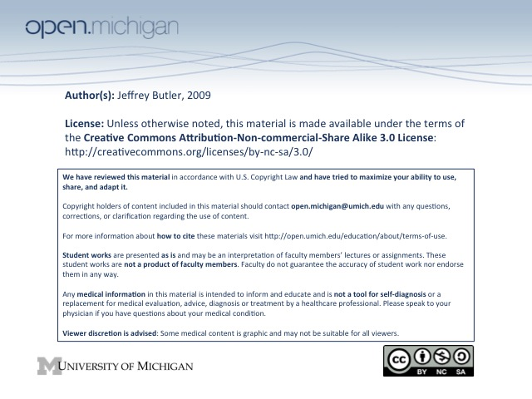
Musculoskeletal, Week 2
November 11, 2009
Weinhold, PowerPoint slides: 102-116, lecture notes p. 346-349

- What are the feedback inhibitors and activators and where in the TCA cycle do they operate?
  - Supply of acetyl-CoA from pyruvate and fatty acid oxidation
    - Acetyl-CoA is the starting material for the TCA cycle, so its supply controls the activity of the cycle
  - NAD+/NADH; increased ratio → increased flux
    - NAD+ is a reactant in the TCA cycle; more reactant drives the reaction forward
  - ADP/ATP; increased ratio →increased flux
    - ADP is a reactant in the TCA cycle; more reactant drives the reaction forward
  - Oxaloacetate concentration
    - The first step in the TCA cycle, a condensation rxn b/w oxaloacetate and acetyl CoA, is catalyzed by the enzyme citrate synthase
    - Oxaloacetate is an allosteric regulator of citrate synthase; binding of oxaloacetate to citrate synthase generates acetyl CoA binding site. So overall, the concentration of oxaloacetate limits/regulates the capacity of the TCA cycle
  - Allosteric feedback
    - NADH is produced by several steps in the TCA cycle and inhibits the cycle at several points via a negative feedback mechanism.
      - NADH inhibits: conversion of pyruvate to acetyl CoA; acetyl CoA→citrate; isocitrate→a-ketoglutarate; a-ketoglutarate→succinyl-CoA (first 3 steps of TCA)
    - Ca2+ activates: pyruvate→acetyl CoA; isocitrate→a-ketoglutarate; a-ketoglutarate→ succinyl-CoA
    - Acetyl-CoA, citrate, succinyl CoA negatively feedback to inhibit the rxn immediately upstream
    - Succinyl CoA also inhibits rxn upstream; inhibits acetyl-CoA→citrate
    - ATP inhibits isocitrate→a-ketoglurate rxn
**main point of regulation is to increase flux when energy demands are high and to decrease flux when energy demands are low

- How are fatty acids delivered to muscle?
  - Fatty acids are either incorporated into triglycerides or bound to albumin in the blood and delivered to muscles

- What are the major fatty acids?
  - Saturated: Palmitic C-16, Stearic C-18
  - Unsaturated: Oleic C-18 (double bond @ C9); Linoleic C-18:2 (double bond @C9,12); A-linolenic C-18:3 (db @ C9,12,15); Arachdonic C-20:4 (db @ C5,8,11,14)

- How are fatty acids transported into cells and within cells?
  - Fatty acids are the second major source of fuel used by cardiac and skeletal muscles; because carbons are completely reduced, oxidation of the carbons releases lots of energy. Carbohydrates are partially oxidized – i.e. have –OH groups – so their oxidation yields less energy than B-oxidation of fatty acids.
  - In the blood fatty acids are present either bound to albumin or as triglycerides; to enter cell they must be soluble, free fatty acids, which can be transported via carrier mediated diffusion or simple diffusion (there will be an equilibrium between bound and soluble FAs). Within cells, as in the blood, they must be carried by fatty acid binding protein (FABP). (makes sense, amphipathic nature of FAs make them good detergent molecules, ie not so good for membrane cohesion!)

- What is the first reaction in the oxidation of fatty acids that have been transported into muscle cells? Where is this reaction located in the cell?
  - Once in cell, acyl CoA synthase transfers the acyl onto CoA, forming acyl-CoA
  - acyl CoA synthase is found in the outer membrane of the mitochondria and in the ER

- How does carnitine function in the oxidation of fatty acids?
  - Carnitine carries acyl groups (12 carbons or longer) into the mitochondrial matrix where fatty acid oxidation occurs; carnitine palmitoyltransferase transfers acyl groups from acyl-CoA onto carnitine on the outer mitochondrial membrane

- How are fatty acids transported into the mitochondria?
  - Once in cell, acyl CoA synthase converts fatty acids to acyl CoA in the outer membrane of mitochondria or in ER. Any fatty acids C-12 or longer will use carnitine as a carrier to get into the mitochondrial matrix: carnitine palmitoyltransferase will transfer the acyl CoA (previously the fatty acid) onto carnitine, which will move through a translocase protein, carrying acyl groups into the matrix
  - Fatty acids C-10 or shorter can diffuse through membrane without carrier

- What is the rate-limiting step in the transport process?
  - The carnitine palmitoyl transferase I complex is the regulated step; regulates the transfer of the acyl-CoA onto carnitine

- What four steps are repeated to generate acetyl CoA from palmitoyl CoA?
      - acyl-CoA→R’-CH2CH=CH-COSCoA; double bond formed is a trans double bond; significant because all naturally formed unsaturated double bonds are cis
        - catalyzed by acyl CoA dehydrogenase
        - forms FADH2
      - hydration: add water across double bond; catalyzed by enoyl CoA hydratase
      - b-hydroxyacyl CoA dehydrogenase catalyzes an oxidation step which produces NADH
      - acyl CoA transferase forms acetyl CoA (2C from acyl group now attached to CoA) and acyl CoA (the acyl chain is reduced by 2 Cs)
*the acetyl CoA is what eventually enters the TCA cycle for further oxidation
(edit: slightly abbreviated version: you have a 16C acyl CoA and you need to break off two carbons to make acetyl CoA. First create a trans double bond between carbons 2 and 3, then convert that to a hydroxyl by adding water across, then oxidize the alcohol to a ketone so you finally have a good substrate for nucleophilic attack by another equivalent of CoASH (sulphur nucleophile) and, voila, acetyl CoA pops off and you’re left with a C14 acyl CoA)

- In the electron transport system, what accepts electrons from the FADH2 generated by fatty acid oxidation?
  - The CoQ complex receives electrons from the FADH2 generated in step 1 in the previous question. (remember that CoQ also receives electrons from FADH2 made in the TCA cycle; it is an important part of the electron transport chain)

