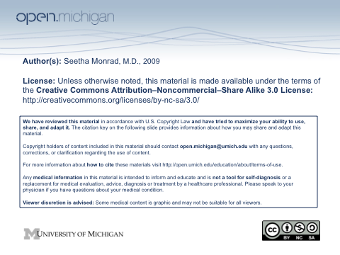

Crystalline Arthritis
November 30, 2009

Seetha Monrad M.D.
Division of Rheumatology
Department of Internal Medicine

Learning Objectives
- Understand the metabolism and renal handling of uric acid
- Know the common causes of hyperuricemia
- Understand the relationship between uric acid and gout
- Describe the typical presentations of the different stages of gout
- Know the treatment modalities for the different stages of gout
- Describe the spectrum of disease associated with calcium pyrophosphate depositions
- Describe the differences between gout and pseudogout

Supplementary references:
- Feig, DI, et al. “Uric acid and cardiovascular risk”. N Engl J Med. 2008 Oct 23;359(17):1811-21.
- Teng, GG, et al. “Pathophysiology, clinical presentation and treatment of gout.” Drugs 2006;66(12):1547-63.

