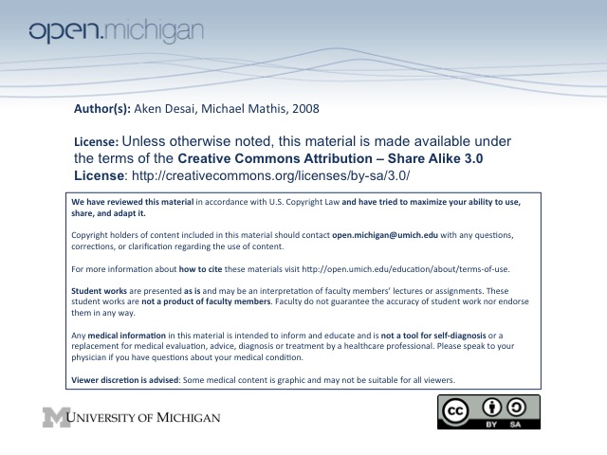
Osteoarthritis
Osteoarthritis Definition
- Osteoarthritis – a degenerative disease of the joint connective tissue characterized by a loss of cartilage and by a thickening/remodeling of subchondral bone resulting in pain and dysfunction.
OA Signs/S_{x}
- Symptoms – involve primarily pain & decreased ROM:
  - Pain – pain related to use, which gets worse during day
  - Stiffness – minimal morning stiffness (<20 min) and after inactivity
  - ROM – decreases over time
- Signs – primarily bony enlargement & joint issues:
  - Bony enlargement – from bony sclerosis & osteophytes
  - Joint – problems with crepitus (creaking), instability, restricted movement, and swelling
OA Diagnosis
- H&P – D_{x} OA based on above signs/symptoms
- X-ray – numerous x-ray findings characteristic of OA:
  - Joint space narrowing – space between bones smaller, can get to bone-on-bone rubbing
  - Marginal osteophytes – circumferential outcropping of bones at joint
  - Bony sclerosis – bone becomes thicker (whiter on x-ray) on edge approximating joint
  - Subchondral cysts – holes in bone close to joint space
  - Malalignment – e.g. varus/valgus deformities, etc.
- Lab Tests – nothing; currently researching tests for cartilage degradation products in serum/joint fluid
OA Risk Factors
- Demographic – highest risk in elderly obese females:
  - Age – 75% of persons over 70 have OA
  - Female Sex – predisposition to bone disorders
  - Obesity – increased loading on joints
- Trauma – previous fractures & bone trauma can lead to OA of joint later in life; surgery too
- Congenital – some hereditary components involved
- NMJ/Metabolic Disorders – can cause 2º OA from disease (DM neuropathy, CPPD)
OA
- Progression – healthy cartilage → mechanical stress/biological predisposition → maladaption → OA
- Distribution – primary OA has a characteristic distribution:
  - Heberden’s Nodes – joint swelling at DIP joints, characteristic of 1º OA
  - Bouchard’s Nodes – joint swelling at PIP joints, characteristic of 1º OA
  - Hip/Knee – also prominent joints for 1º OA
  - Carpometacarpal joints – at base of hand, characteristic of 1º OA
  - Excluded – OA less likely to occur in ankles, elbows, metacarpophalangeal (MCP)/MTP joints
  - Exception – MTP joint of big toe sometimes involved in 1º OA
- Hip Joint OA vs. Bursitis:
  - Hip Joint OA – pain radiates down medial thigh
  - Hip Joint Bursitis – inflammation of join space, pain radiates down lateral thigh
2º OA
- 2º OA – osteoarthritis sometimes presenting in an unusal “wrong” joint, precipitated by different factors:
- Trauma/Overuse – if joint involved in previous trauma, or is specifically overused for some reason → OA
- NMJ/Diabetic Neuropathy – has a lower extremity bias → often midfoot involvement, MTPs
- Metabolic Disorders – 1º calcium pyrophosphate deposition disease (CPPD), but many other metabolic
- CPPD – (pseudogout) has an upper extremity bias → most often MCPs, wrist also involved
OA Management
- D_{x} – make sure disease is OA, and not bursitis or tendonitis
- Decrease Pain – pain is often limiting factor in OA, and if decreased will increase function
- Activity – mild exercise will promote joint strength/stability, and weight loss will reduce loading on joints
OA R_{x} Management
- No Cure – pharmacological treatments are not disease-modifying, only alleviate symptoms
- Non-opioid R_{x} – include acetaminophen, NSAIDs, COX-2 Inhibitors
  - Acetaminophen – first line pain relief, comparable to NSAIDs; although liver toxicity SE
  - NSAIDs – also a first line agent, can try different kinds to see if patient responds; GI/CV SE
  - COX-2 Inhibitors – a selective NSAID, very similar response/SE
  - Tramadol – a non-opioid, but affects opioid/serotonin pathways, used in addition to NSAID; nausea SE
- Opioid R_{x} – include codeine, oxycodone, propoxyphene, morphine/fentanyl
  - Codeine, Oxycodone – 2nd level treatments, less risk of addiction than people think
  - Propoxyphene – pretty good, but weaker
  - Morphine, fentanyl patches – 3rd level treatments, for severe pain interfering with ADLs/sleep
OA R_{x} Management, Cont
- Topical Agents – include hot/cold patches, capsaicin-topicals, liniments
  - Hot/cold patches – for relief of breakthrough pain
  - Capsaicin-containing topicals – can deplete substance P inducing pain, good evidence support
  - Liniments – methyl salicylates; sort of like icy-hot
- Intra-articular – include steroid & hyaluronate injections
  - Steroids injections – subacute T_{x} reducing pain 1-3 months, risk of infection
  - Hyaluronate injections – new idea, limited to knees to provide relief
- Polysulfated Glycosaminoglycans – a “nutriceutical” cartilage precursor → slows loss/degradation?
OA Surgical T_{x}
- Arthroplasty – a joint remodeling, involving removing rough edges/cysts of surface, osteophytes
- Osteotomy – resect a wedge of bone to re-align weight distribution on joint
- Total Joint Replacement – prosthetic joint, last-ditch effort

