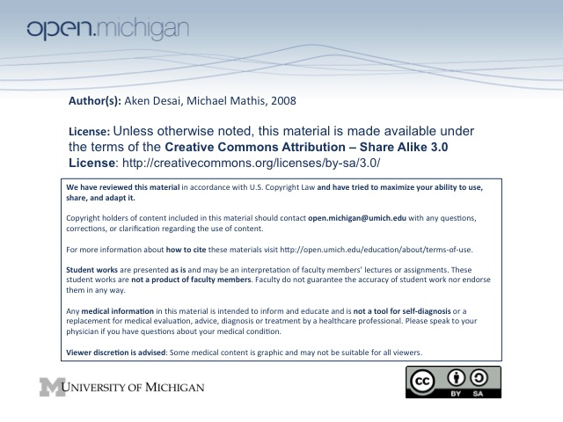
Musculoskeletal Pathology #1
Bone Cell Review
- Osteoblasts – prescursor cells, line up along border of bone…
- Osteocytes – mature cells controlling Ca⁺/Phosphate
- Osteoclasts – multinucleated Giant cells → bone resorption;
- Osteoid – Type I collagen
Bone Types
- Woven Bone – immature weak bone, never found in normal adult; only in fetal bone, growth plate
  - Fractures & infection – woven bone can present here again, but weak
- Lamellar Bone – mature regularly arranged sheets of bone
- Cortical Bone – dense compact bone, most of skeletal, very strong
- Cancellous Bone - spongy trabecular bone
Bone Anatomy
- Diaphysis – long shaft of bone; thinner → cortical bone outside, cancellous bone inside
- Metaphysis – end of medullary cavity of bone.endosteum → bone growth occurs here, also disease-prone
- Epiphysis – end of bone, contains mostly spongy bone
  - Surface – hyaline cartilage
Compact Bone
- Haversian System – concentric bony lamellae with canals containing osteocytes
- Volkmann’s Canals – connect Haversian canals between systems; extend laterally
- Osteocytes – rest of bone outside of Haversian canals
Cancellous Bone
- Spongy bone, no osteoblasts/clasts → no turnover really, just osteocytes
- Trabeculae separated by _____
- Spicules – bone depositions, marrow in between
Cartilage
- Chondroblasts – precursor cartilage-forming cells, make new matrix
- Chondrocytes – mature cells in lacunae maintaining cartilage
- ECM – proteoglycans
- Types: Primarily hyaline cartilage
  - Hyaline Cartilage – in joints, growth plates
  - Fibrocartilage – spinal discs
  - Elastic cartilage - larynx
Bone Review
- Bone Formation
  - Osteoclasts have to clean up debris & remodel
  - Osteoblasts lay down osteoid, become trapped in surrounding bone tissue
- Intramembranous Bone Formation – formed in fracture repair
- Endochondral Bone Formation
  - Occurs within a cartilage model first → common in long bones, axial bones
  - Occurs in fracture repair
  - 1º ossification centers – in middle
  - 2º ossification centers – at edge within cartilage cap in epiphysis
- Growth Plate
  - Cartilage → Proliferation → Hypertrophy → Calcification → Bone
- Periosteal Bone Formation – deposits between periosteum & bone

