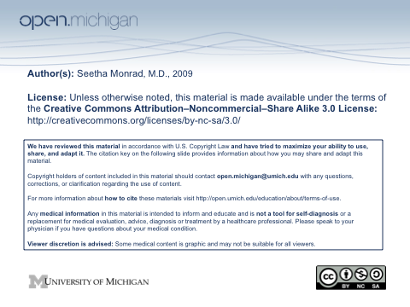

Other Inflammatory Arthritides
December 2, 2009

Seetha Monrad M.D.
Division of Rheumatology
Department of Internal Medicine

Learning Objectives
- List the common features of seronegative spondyloarthropathies, and how they differ from rheumatoid arthritis
- Describe the cardinal clinical and radiographic features of ankylosing spondylitis
- Describe the distinguishing features of psoriatic arthritis, IBD-associated arthritis and reactive arthritis
- Understand the association of HLA-B27 with spondyloarthropathies, and why it is not commonly used clinically
- List the risk factors for septic arthritis
- Describe the presentation, diagnosis and management of septic arthritis
- Describe the presentation of gonococcal arthritis, and how it differs from other types of bacterial arthritis
- Know the spectrum of microbes that can cause infectious arthritis

