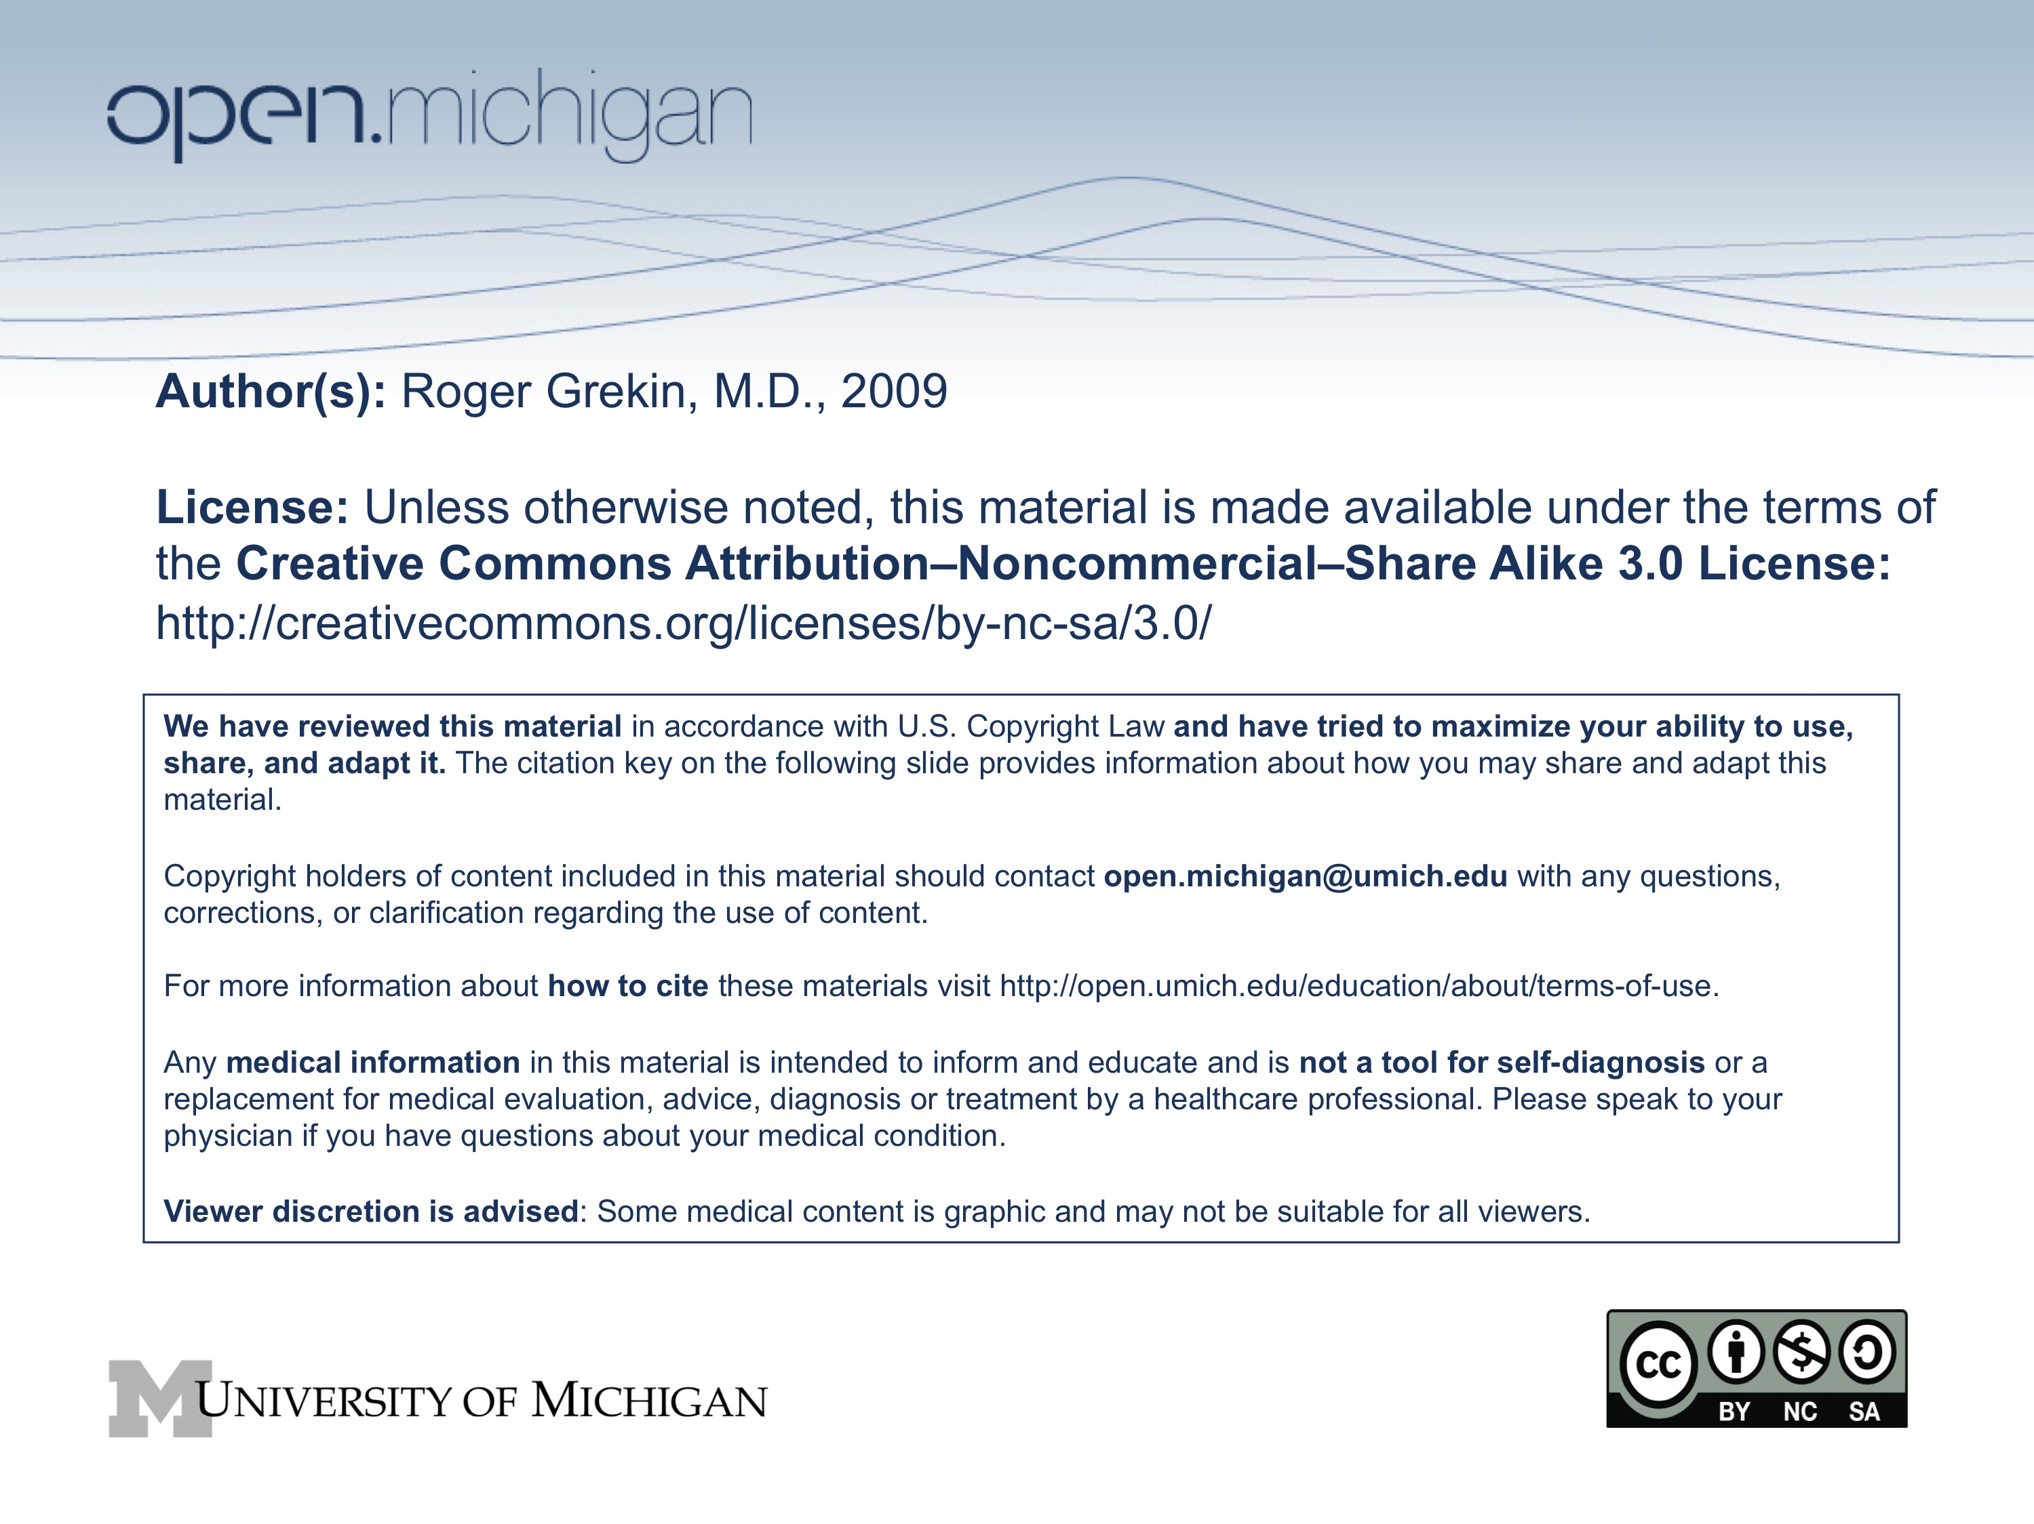

Topic: Metabolic Bone Disease; Fall 2008; M2 Musculoskeletal

Faculty: Roger J. Grekin, M.D.
Department of Internal Medicine

Key words: bone, osteoporosis, osteomalacia, rickets, Paget’s disease, estrogen, bisphosphonates

Learning objectives

A. Understand the regulation and function of osteoblasts and osteoclasts
B. Define osteoporosis and identify the major risk factors for its development
C. Describe appropriate diagnosis and treatment of osteoporosis
D. State the major causes and pathophysiology of osteomalacia
E. Describe the clinical manifestations of osteomalacia and rickets
F. Describe the laboratory and clinical manifestations of Paget's disease of bone

Sample test question

A 40 year old woman with asthma and anxiety takes prednisone, 40 mg daily, albuterol inhalers, replacement thyroid hormone therapy and multivitamins. She has irregular menses, occurring every 4 to 6 weeks. She now presents with back pain and a compression fracture at T12. The most important cause of osteoporosis in this woman is likely to be:

A. Prednisone therapy
B. Thyroid hormone therapy
C. Estrogen deficiency
D. Vitamin D deficiency
E. Malnutrition
METABOLIC BONE DISEASE

Roger J. Grekin, M.D.

I. Regulation of bone metabolism

A. Bone structure
1. Extracellular matrix
a. Osteoid (type 1 collagen)
b. Mineral crystals

2. Bone architecture
a. Cortical bone
b. Trabecular (cancellous) bone

B. Cells in bone

1. Osteoblasts
a. Arise from connective tissue progenitors
b. Produce extracellular matrix proteins: type 1 collagen and osteocalcin
c. Responsible for mineralization: alkaline phosphatase
d. Stimulated by growth factors: TGF-ß, IGF-1

2. Osteoclasts
a. Multinuclear cells arising from hematopoietic precursors
b. Contact with bone at ruffled border: acid environment and lysosomal enzymes
c. Activity stimulated by IL-1, IL-6 and TNF
d. Role of gonadal steroids in the inhibition of osteoclast activity

3. Bone remodeling
a. Begins with osteoclastic activity (7-10 days)
b. Followed by osteoblastic bone reformation (3 months)
c. Mechanical loading is an important stimulus
d. Immobilization increases resorption and blocks formation

II. Osteoporosis

Case #l

A 67 year old woman presents with acute lower back pain of one day duration. She has tenderness over the lumbar spine and limitation of back motion. There is no evidence of Cushing's syndrome. Neurologic exam is normal. Spine films demonstrate a compression fracture at L2. She underwent menopause at age 50. She has been healthy all her life and takes no medications. Her mother and an aunt both had osteoporosis. Calcium, phosphate, alkaline phosphatase, thyroid function, and protein electrophoresis are normal.

A. Definition: Osteoporosis is a clinical syndrome caused by a decrease in bone mass. The remaining bone is histologically normal.

B. Etiology
1. Maximal bone density attained in early adulthood
2. Steady loss of bone thereafter
3. Bone loss is accelerated by estrogen or
testosterone deficiency
4. Polymorphism of the vitamin D receptor predicts
increased risk of osteoporosis
5. Positive family history, thin body habitus, Caucasian or Asian race, fair skin and cigarette smoking all predict increased risk
6. Glucocorticoids inhibit GI calcium absorption, osteoblast activity and bone matrix formation. They also induce hypogonadism.

C. Clinical manifestations

1. Early osteoporosis is asymptomatic
2. As skeletal integrity declines, fractures occur, often with minimal trauma
3. Trabecular bone is more vulnerable than cortical bone. Vertebral compression fractures are most common, hip and wrist fractures also are major problems
4. End stage disease associated with marked dorsal kyphosis. There may
also be loss of lumbar lordosis

D. Incidence

1. 40% of 50 year old Caucasian and Asian women will have an osteoporotic fracture during their lifetime
2. 13% of men and Black women will have such a fracture
3. 1/3 of these fractures will be hip fractures, a condition associated with 5-20% mortality

E. Diagnosis

1. Plain films are very poor measurements of bone density
2. Bone density best measured with bone densitometry measurements (DEXA)
3. Criteria for diagnosis is bone density more than 2.5 standard deviations below the mean for young normals
4. Bone markers
a. Osteoblast: Alkaline phosphatase and osteocalcin
b. Osteoclast: Pyridinoline crosslinks and N-telopeptide

F. Evaluation of patients with osteopenia; exclude known
causes of osteopenia

1. Hyperparathyroidism
2. Cushing's syndrome
3. Hyperthyroidism
4. Osteomalacia
5. Multiple myeloma
6. Hypogonadism, both in men and women

G. Prevention

1. Adequate calcium intake in susceptible individuals
2. Avoid hypogonadism
3. Weight bearing exercise
.
H. Treatment

1. Fall prevention
2. Calcium supplementation
3. Vitamin D
4. Gonadal steroid replacement

a. Major, well established effects to decrease osteoclastic activity
b. Long term estrogen therapy increases bone mass and decreases fracture risk

5. Raloxifene

a. A selective estrogen receptor modulator (SERM) which mimics estrogen action on bone, but does not have trophic effects on breast or endometrium
b. Significant increase in bone density, but probably not as potent as estrogen.
c. Decreased fracture risk
d. Does not have trophic effects on breast or endometrium, and does not appear to increase the risk of breast or endometrial cancer.
e. Commonly causes hot flashes.
f. Associated with increased risk of thromboembolic disease.

6. Bisphosphonates

a. Alendronate, risedronate, ibandronate and zoledronic acid
b. Potent inhibitors of osteoclast activity, mechanism of action is uncertain. Thought to act by binding to hydroxyapatite crystals and stabilizing bone matrix. Recent studies suggest they may inhibit cholesterol metabolism within the osteoclast
c. Alendronate, risedronate and ibandronate are orally administered, and may be given daily, weekly or (for ibandronate) monthly. Zoledronic acid and ibandronate may be given as an intravenous infusion
d. Promote sustained increase in bone mass and decreased fracture risk in postmenopausal and glucocorticoid -induced osteoporosis
e. Rare instances of severe erosive esophagitis

7. Calcitonin:

a. Receptor mediated osteoclast inhibitor. Slows bone loss,
usually does not restore bone
b. Available as a nasal spray
c. May provide pain control for acute fracture
d. Generally well tolerated; occasional nausea, vomiting, flushing

- 8. Parathyroid Hormone (Teriparatide)

  - a. Promotes osteoblastic activity; parathyroid hormone effects on bone are complex. Sustained elevations cause bone loss, but acute elevations stimulate bone formation.
  - b. Given as a daily subcutaneous injection
  - c. Results in striking improvements in bone density and decreased fracture risk
  - d. Risk of hypercalcemia appears to be modest
  - e. Increased incidence of osteosarcoma in rats
  - f. Should not be given together with bisphosphonates

9. Devices and physical therapy

10. Prevention in patients receiving long term glucocorticoid therapy

a. Adequate calcium and vitamin D
b. Gonadal steroid replacement if indicated
c. Bisphosphonates

III. Osteomalacia and Rickets

CASE #2

A 47 year old man had resection of 15 feet of small intestine 10 years earlier for inflammatory bowel disease. He was admitted for evaluation of recurrent fractures; four in the past 18 months. Two of the fractures were not associated with any apparent trauma.

On physical exam he was 5'10", 124 lbs. He had generalized bone tenderness.

Ca = 8.6 mg/dl (8.5-10.5) PO4 = 1.2mg/dl (3.0-4.5), Albumin = 3.7 gm/dl (3.5-4.5), Hgb = 9.7 gm/dl (13-15), Carotene = 37 mg/dl (100-200), cholesterol = 107 gm/dl (160-250), Alkaline phosphatase = 382 (under 100).

A 72 hour fecal fat was 28 gm (under 5). Serum parathyroid hormone was 482 pg/ml (10-65). Serum 25 hydroxycholecalciferol levels were unmeasurable. Bone biopsy showed increased osteoid seams.

He was treated with high dose vitamin D and calcium tablets with some improvement in bone pain. No further fractures were seen over the following year.

A. Definition: Osteomalacia and rickets are the clinical syndromes which result
from inadequate bone mineralization. Rickets is the term used to define the syndrome in children, osteomalacia is used in adults.

B. Etiology

1. Vitamin D deficiency or resistance

a. Inadequate intake and sunlight
b. Malabsorption
c. Severe liver disease
d. Renal failure
e. Hereditary syndromes

2. Phosphate deficiency

a. Renal tubular disorders
b. Tumor associated osteomalacia
c. X-linked hypophosphatemia
d. Phosphate binders

3. Inhibitors of mineralization

a. Aluminum
b. Fluoride

C. Pathogenesis

1. Vitamin D deficiency leads to decreased absorption of calcium by the GI tract.
2. As serum calcium starts to fall, secondary hyperparathyroidism occurs.
3. Elevated Pth levels may maintain serum calcium in the normal range,
but at the cost of phosphaturia, hypophosphatemia and increased bone reabsorption
4. Low serum phosphate results in inadequate bone mineralization and osteopenia.
5. In severe cases, secondary hyperparathyroidism is not adequate to maintain serum calcium levels, and hypocalcemia occurs.

C. Clinical Manifestations

1. Bone pain and tenderness, pathologic fractures
2. Muscle pain and weakness
3. Decreased bone density
4. Hypophosphatemia, increased alkaline phosphatase, and increased PTH
5. Late hypocalcemia
6. Pseudofractures
7. In children, bowing of the legs and rachitic rosary, short stature

D. Therapy: Treat the underlying disorder. Patients with vitamin D deficiency should receive vitamin D replacement; patients with renal failure need 1,25 dihydroxycholecalciferol

IV. Paget's disease of bone

Case #3

A 52 year old man is referred for evaluation and treatment of right hip pain. He has had progressively worsening pain over the past 45 years. He also notes a deformity of the right lower leg. He has limitation of flexion and internal rotation of the hip and pain with motion. There is marked bowing of the right tibia with increased warmth. Bone scan shows increased activity throughout the pelvis, right acetabulum, right tibia, and skull. Plain films demonstrate typical Pagetoid changes in these areas.

A. Common disorder of increased bone turnover

1. Etiology unknown
2. Increased bone resorption with compensatory
increased bone formation leads to thick, abnormal bones

B. Clinical manifestations

1. Many patients asymptomatic
2. Bone pain and deformity
3. Fractures
4. Arthritis
5. Nerve compression
6. Osteogenic sarcoma

C. Diagnosis

1. Increased alkaline phosphatase
2. Characteristic radiographic appearance
3. Bone scan to determine extent of disease

D. Treatment

1. Only indicated for symptoms
2. Bisphosphonates and calcitonin are often helpful

