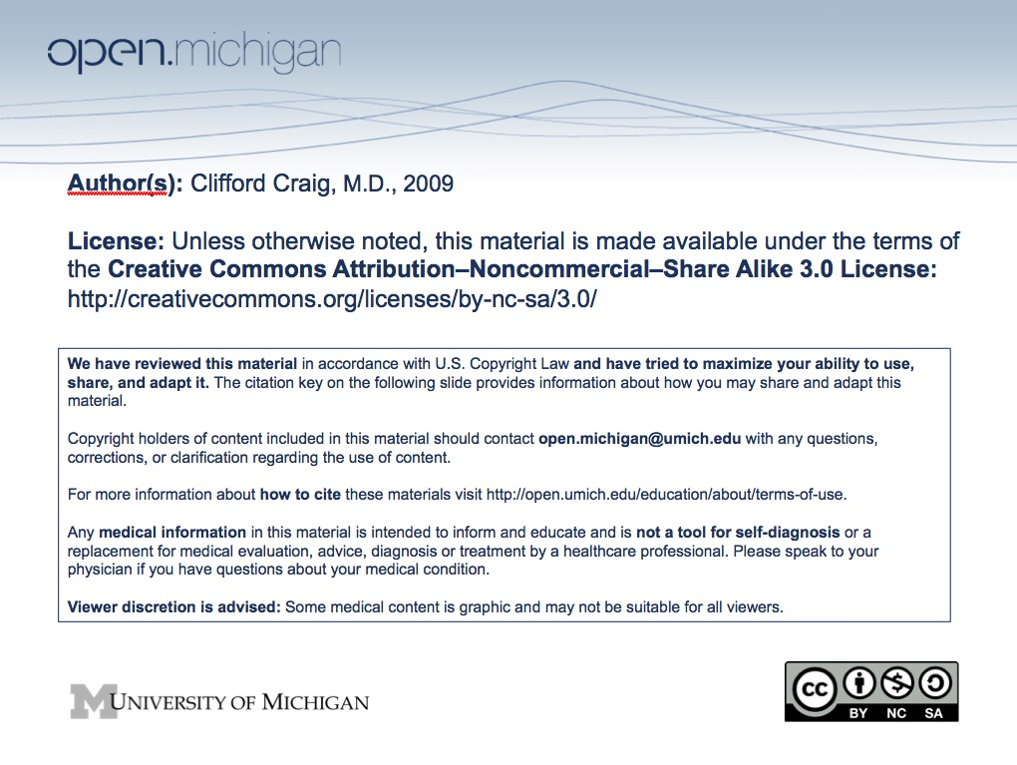
COMMON MUSCULOSKELETAL PROBLEMS –
GROWTH AND DEVELOPMENT – PATHOLOGIC VS. NORMAL
Clifford L. Craig, M.D.
M2 Musculoskeletal
Fall 2008
- ANGULAR AND TORSIONAL DEFORMITIES OF THE LOWER LIMBS
Examination
Relaxed, define terms
Supine/sitting/walking
Each joint individually
Beware of asymmetrical findings
1. IN-TOEING:
- Metatarsus adductus --- newborn - 18 months
Limited to forefoot - 80% improve spontaneously
- Internal tibial torsion --- 6-18 months
Related to sleeping position
85% improve spontaneously
Transmalleolar axis: Infant 5°, adult 22°
- Femoral anteversion --- 3-9 years
Not a “hip problem”
Improves spontaneously until age 12

- Differential Diagnosis
      - Clubfoot
      - Atavistic first toe (“smart toe”)
      - Z-foot
      - Neurologic problems - i.e., myelodysplasia, cerebral palsy
2. OUT-TOEING:
- Calcaneovalgus foot improves spontaneously
- External tibial torsion
Uncommon, often associated with neurologic problems
i.e., CP, myelodysplasia
- External rotatory contracture of the hip
Improves spontaneously in the first year
3. BOWLEGS/KNOCK KNEES (Genu Varus, Genu Valgus)
- New Patient Evaluation
Clinical
- Presence or absence of knee joint laxity
- Motion of all lower extremity joints
- Location of the angulation - tibia, femur, joint
- Assessment of alignment - anterior-posterior, lateral and rotation
Radiographic
- Long films, anterior-posterior standing, neutral rotation for alignment (?lateral)
- Avoid squeezing the patient onto the X-ray
Laboratory
- Renal function studies (BUN, serum creatinine), calcium, phosphorus, alkaline phosphatase

- Bowlegs (Genu Varus)
  - Differential Diagnosis
Physiologic
Blount's disease, infantile and adolescent forms
Rickets
Metaphyseal chondroplasia
- Physiologic Bowlegs
  - Normal in infants (avg. 15°) and should resolve, or at least attain neutral alignment by 18-24 mos.
  - Salenius and Vankka chart is key to the clinical evaluation (enclosed).
  - X-rays normal except for bowing.
- Infantile Blount's Disease
  - Clinical variables
    - Age, angle, Langenskold stage, degree of internal tibial torsion and obesity.
    - Etiology is currently believed to be internal tibial rotation coupled with bowlegs and early walking leads to increased shear stress on the medial plateau.
  - X-rays
    - Medial beak is the first radiographic finding.
    - If untreated, will progress through the Langenskold stages I-V (increasing depression of the medial plateau), culminating at Stage VI - medial fusion.
    - Metaphyseal/diaphyseal angle (Drennan). 11° or more indicates progressive deformity.
- Adolescent Blount's Disease
  - Typically obese, skeletally immature teenager.
  - Increasing varus deformity with widening of the epiphyseal plate medially.
  - Bracing seldom effective, osteotomy preferred.
- Other Causes
  - Rickets - nutritional, vitamin D resistant, renal; usually can be diagnosed both clinically and radiographically
  - Metaphyseal chondroplasia - usually involves other long bones, and symmetric

- Knock Knees (Genu Valgum)
  - Differential diagnosis: late onset of bone weakness
    - Renal osteodystrophy
    - Metabolic disease
    - Bone dysplasia (storage diseases)
    - Tumor - osteochondroma, fibrous dysplasia
    - Trauma, idiopathic

REFERENCES

1. Salnius, P. and Vankka, E.: The Development of the Tibiofemoral Angle in Children. J. Bone Joint Surg 57A:259-261, 1975.

2. Schoenecker, P.L., Meade, W.C., Pierron, R.L., Sheridan, J.J. and Capelli,
A.M.: Blount's Disease: A Retrospective Review and Recommendations
for Treatment. J. Pediatr Orthop 5:181-186, 1985.

3. Thompson, G.H., Carter, J.R. and Smith, C.W.: Late Onset Tibia Vara: A Comparative Analysis. J. Pediatr Orthop 4:185-194, 1984.

- Developmental Dysplasia of the Hip (DDH)
Etiology - multifactorial - not always congenital or dislocated
“A continuum of dysplasia”
      - Mechanical factors - small space (first born), tight abdominal wall, breech
presentation (60%), left hip (67%), torticollis (20%), metatarsus
adductus/calcaneovalgus (10%)
- Physiologic factors - female (6:1), hormones - estrogen, relaxin (inherited)
- Environmental - cradle boards, swaddling
Hip at Risk
Major Minor
Abnormal clinical examination Limitation of hip abduction at
Breech delivery birth or later
First born - female Sacral dimple
Family history of DDH Foot deformity
Torticollis, scoliosis and other postural deformities

Newborn to 2 months
Ortolani and Barlow tests most reliable
X-rays seldom diagnostic (false negative 50%)
Ultrasound - non-invasive (neonate to 6 months)
Operator dependent, may be too sensitive
(immature vs. abnormal)
Good for follow-up in brace

Method of Examination: (should be part of every well-baby exam)
- Infant is in relaxed, supine position; one hand stabilized the pelvis
- Hip is flexed to 90 degrees and adducted past the midline while gentler outward pressure is made with the thumb (Figure A)
- Hip is then abducted and gently lifted toward socket (Figure B).
- Hip may be felt (not heard) to dislocate or sublux (Figure A) or relocate (Figure B). Not just a test of abduction

Figure A Figure B

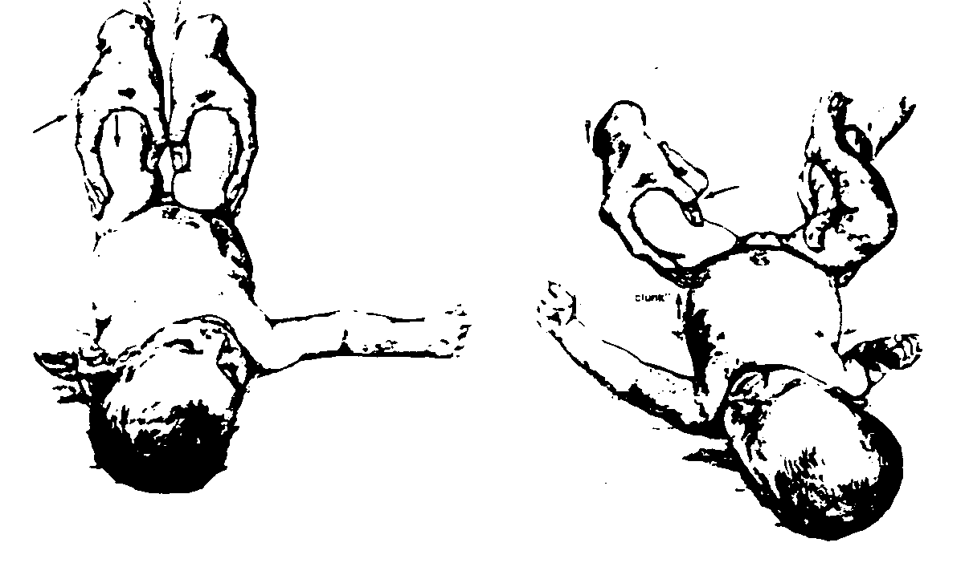
Source: Undetermined

Two months to 2 years: Findings increase with age
Clinical:
Tight adductors Uneven knees (Allis sign)
Shortening Limp (+ Trendelenburg)
Positioning Waddling gait
Abnormal skin folds

Radiographic: More evident after six weeks of age (unreliable before)
Shenton’s line broken
Proximal and lateral migration of the femoral head
False acetabulum (acetabular dysplasia)

Treatment: Newborn to 6 months (Ortolani positive - reducible)
Gentle reduce femoral head into acetabulum (Ortolani)
Maintain the abducted and flexed position (human position of Salter)
Satisfactory reduction must be documented (x-ray/ultrasound)

Pavlik harness
The Pavlik harness prevents redislocation, yet maintains the
flexed-abducted posture
Flex hip above 90 degrees
The posterior strap is a “checkrein” to prevent adduction
and allows the hips to fall loosely into abduction (safe
zone of Ramsey)
Excessive tightening of the posterior strap (frog position)
may lead to avascular necrosis
Document reduction with x-ray or ultrasound

REFERENCES

- Clarke, N.M.P., et al., Ultrasound screening of hips at risk for CDH: Failure to reduce the incidence of late cases. J Bone Joint Surg, 71-B:9-12, 1989.

- Hensinger, R.N., Congenital dislocation of the hip. CIBA Symposia, Vol 31, No 1, 1979.

- Mubarak S., et al., Pitfalls in the use of the Pavlik harness for the treatment of congenital dysplasia, subluxation and dislocation of the hip. J Bone Joint Surg, 63-A:1239, 1981.

- Race, C. and Herring, J.A., Congenital dislocation of the hip: An evaluation of closed reduction. J Pediatr Orthop, 2:166, 1983.

III Idiopathic Scoliosis

The incidence of idiopathic scoliosis is 22 per 1,000. However, only four of the 22 will require treatment, and only one will require surgery. As a consequence, “clinical sorting” is a significant problem in office management as the majority of children (85%) will require only observation.
Sorting should occur at every level of processing:
Discovery - School Screening
Initial Exam - Family MD or Pediatrician
Disposition - Orthopaedist

Etiology - Genetic
80% - Positive family history
Dominate - (? x-linked)
Variable expressively
High degree of penetrance
Boys and Girls - equally affected

Clinical Evaluation
Anterior-Posterior Alignment
Types of curves - right thoracic, long dorsolumbar, double thoracic,
left double major (right thoracic, left lumbar)
Trunk alignment and “shift”
Rib hump, best evaluated with forward bending test. Documented
using flexicurve, Scoliometer (Bunnell), variety of photographic/computer techniques, Moire, ISIS, etc.
Sagittal Alignment
Thoracic lordosis - decreased pulmonary function
Kyphosis (normal up to 40 degrees)
Lumbar lordosis (spondylolysis/spondylolisthesis)

Radiological Evaluation
Standing PA and lateral x-rays (initial), long films preferred
Measurement of the curvature using Cobb method
Exact positioning, avoid repeat films, timing, shielding
Risser grading for skeletal maturity

Beware of:
Painful scoliosis
Progressive curvature in boys
Curve that goes the wrong way (left thoracic)
Rapid progression, i.e., more than 1 degree per month

REFERENCES

1. Lonstein, J.E., Carlson, M.D.: The Prediction of Curve Progression in Untreated Idiopathic Scoliosis During Growth. J Bone Joint Surg 66A:1061-1071, 1984.

2. Phillips, W.A., Hensinger, R.N.: Chapter 14, Fusion Techniques for Scoliosis. In: SPINE FUSION SCIENCE & TECHNIQUES. Cotler and Cotler, Springer-Verlag, New York, 1990.

3. Weinstein, S.L., Ponseti, I.V.: Curve Progression in Idiopathic Scoliosis. J Bone Joint Surg 65A: 447-445, 1983.

