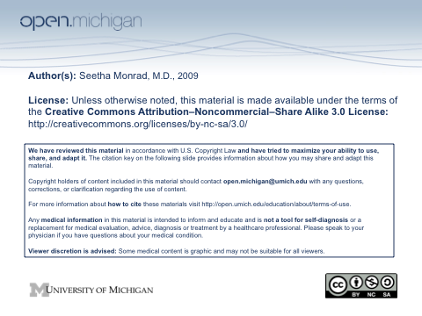

Evaluating diffuse aches and pains
December 9, 2009

Seetha Monrad M.D.
Division of Rheumatology
Department of Internal Medicine

Learning Objectives
- List several common systemic causes of diffuse aches and pains, and develop a framework for evaluating a patient who presents with them
- Know the features of patients presenting with polymyagia rheumatica and inflammatory myopathies, and how they differ from fibromyalgia (FM)
- Identify the clinical features commonly seen in individuals with FM
- Understand the concept of central pain, as opposed to nociceptive and neuropathic pain
- Know which systemic and regional syndromes can overlap with FM
- Describe some of the likely pathogenic mechanisms involved in FM
- Describe the principles of FM management
- List which classes of medications play a role in the treatment of FM, and which do not

