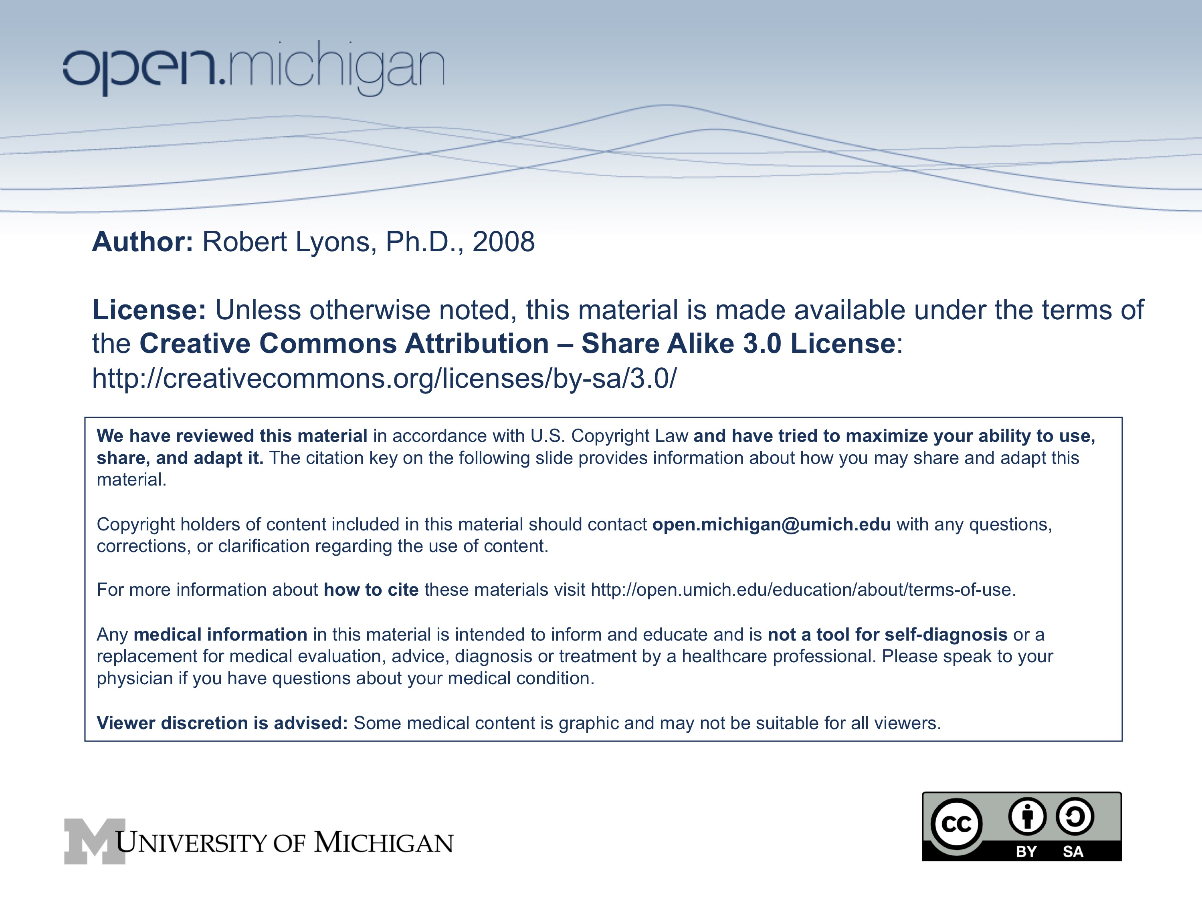
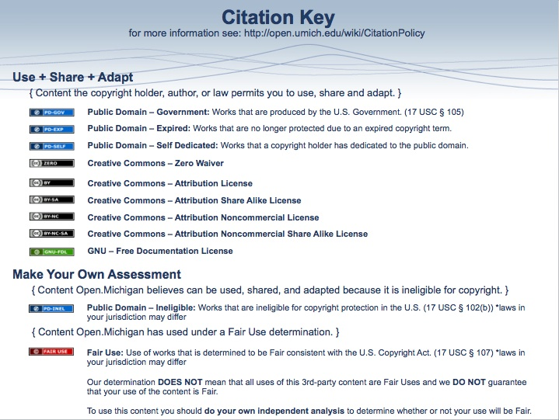

Folate and AdoMet One-Carbon Pools Dec 11-12, 2008 Dr. Robert Lyons

See: http://seqcore.brcf.med.umich.edu/mcb500 for supplementary course materials.

Medical relevance of the one-carbon pathways
Mechanism of antibiotics
Sulfa drugs - antibacterial
Trimethoprim, pyrimethamin - antibacterial, antimalarial
Pathologies
VitB12 deficiency/pernicious anemia
dietary folate deficiency
sprue
(See also the Nucleic Acid lectures for anti-cancer chemotherapies)

I. Tetrahydrofolate as a carrier of one-carbon units

A. Obtaining folate - an essential vitamin

1. Dietary sources (green veggies, fortified cerals, liver) provide folic acid. Cleaved by enzyme 'conjugase' to remove extra glutamate residues, absorbed, reduced to dihydrofolate, then to tetrahydrofolate by Dihydrofolate Reductase (DHFR). DHFR inhibitors are useful antibiotics if they affect other organisms but not humans.

2. Inhibitors of DHFR are used therapeutically: e.g. methotrexate (cancer chemotherapy). Tumors that resist methotrexate sometimes have amplified the DHFR gene to compensate for the inhibitor.

3. Compounds that inhibit bacterial folate biosynthesis can be excellent antibiotics.
Example: sulfa drugs like sulfanilamide:

B. Main entry of one-carbon units - N5, N10 methylene tetrahydrofolate

1) Serine conversion to glycine:

2) Glycine conversion to CO2 and NH4(+) :

C. Oxidation states of the one-carbon unit and inter-conversions
(reversible reactions indicated by double-ended arrows)

II. S-adenosylmethionine ('SAM', aka 'AdoMet') Overview:

A. Biosynthesis of methionine
(see also the Amino Acid Metabolism handout)

B. Re-utilization of folates:

C. Synthesis of S-Adenosyl Methionine

D. Uses of SAM - biological methylator

Example: Conversion of norepinephrine to epinephrine:

Others: Conversion of phosphatidylethanolamine to phosphatidylcholine, methylation of mRNA and DNA

E. AdoMet cycle

III. Pathologies:

A. Folate deficiency is common. symptom: megaloblastic anemia
weakness, anemia, anorexia
Appearance of large, immature erythrocytes ('megaloblasts') in the blood

B. several causes:

- dietary deficiency common
- alcoholism may compound folate deficiency
- inability to absorb folates (e.g. tropical sprue and non-tropical or celiac sprue)

Dietary folates are typically poly-glutamated (up to 6 γ-glutamyl residues)
We can absorb only the mono-glutamyl form
An enzyme 'conjugase' secreted by the brush border cells of the intenstine hydrolytically removes the extra glu residues so we can absorb the folate
Intestinal irritation can compromise production of conjugase

- possibly secondary to B12 deficiency: pernicious anemia

'Methyl trap' hypothesis and deficiency of vitamin B12:

B12 deficiency can be caused by autoimmune response to 'Intrinsic Factor', a product of the gut that aids in the absorption of B12.

