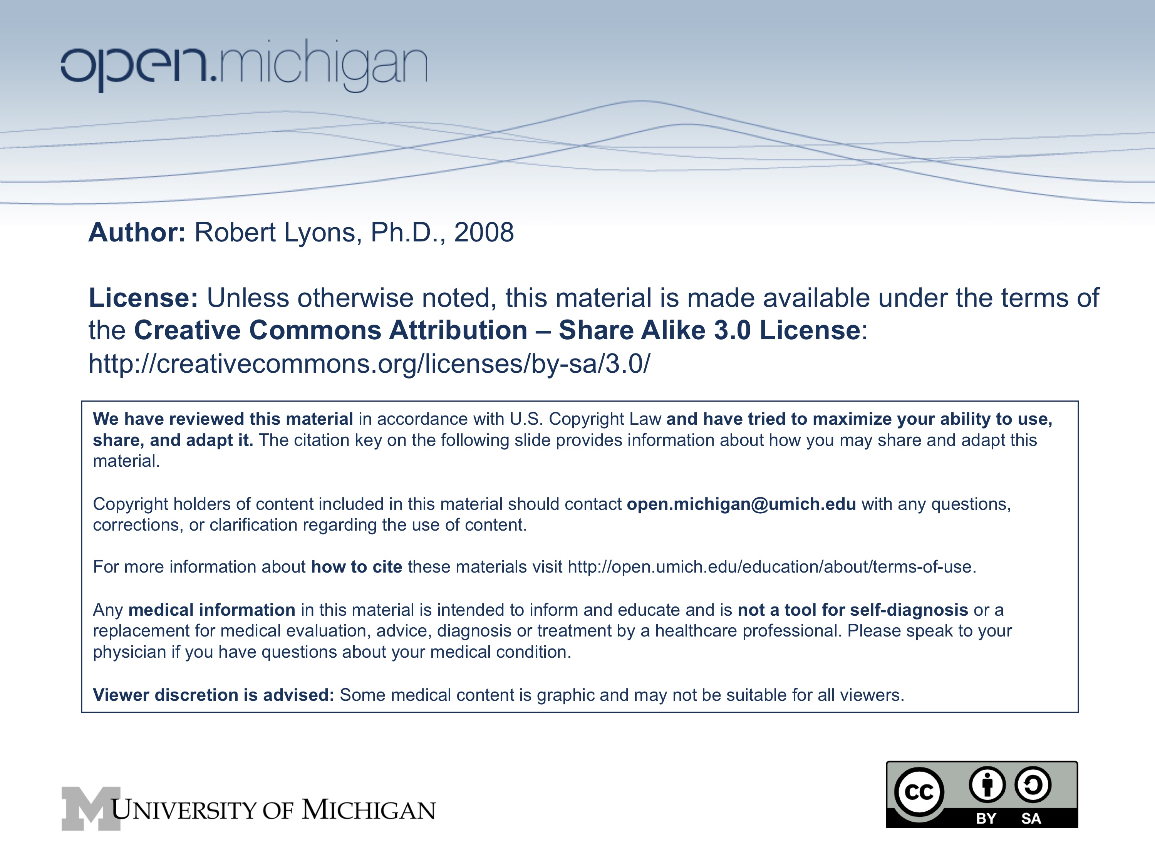
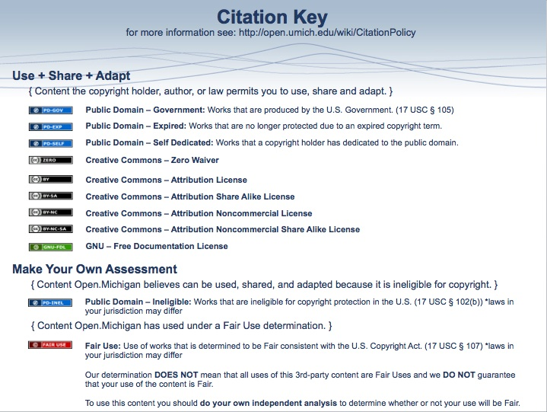
Nucleotide Metabolism December 12-17, 2008 Dr. Robert Lyons

See: http://seqcore.brcf.med.umich.edu/mcb500 for supplementary course materials.

Medical relevance of nucleotide pathways
Critical in cancer treatment
Hydroxyurea, anti-folates, FdUMP, 5-FU, etc
Antiviral therapies
acyclovir and herpes
Important inborn errors and pathologies
Adenosine deaminase and SCIDS
Lesch-Nyhan Syndrome
Hyperuricemia

I - Purine Nucleotides: Biosynthesis, Degradation and Salvage

A. De-novo biosynthesis of purine nucleotides

1. Inosine monophosphate synthesized de-novo by adding onto ribose - phosphate

a. First step - and regulated step - is conversion of ribose-5-phosphate to phosphoribose-1- pyrophosphate (PRPP).

b. The pyrophosphate 'activates' the C1 on the ribose for further addition:

c. Synthesis proceeds to inosine monophosphate:

Other compounds contribute to synthesis, including:
- N¹⁰-formyl THF *******
- glycine
- glutamine
- aspartate.

2. IMP is converted to either AMP or GMP by divergent pathways

a. Converting Inosine-M-P to Adenosine-M-P:

b. Converting Inosine-M-P to Guanosine-M-P:

3. phosphorylation gives diphosphate form (nucleoside monophosphate kinases)

AMP + ATP <--> 2ADP (adenylate kinase)

GMP + ATP <---> GDP + ADP (guanylate kinase)

- similar enzymes specific for each nucleotide
- no specificity for ribonucleotide vs. deoxyribose.

4. deoxynucleotides formed by reduction of the sugar (ribonucleotide reductase)

a. Free radical mechanism
b. Hydroxyurea is a RR inhibitor
- free radical scavenger
- inhibits ribonucleotide reductase
- useful in chemotherapy

5. phosphorylation to triphosphate (nucleoside diphosphate kinase)

N1DP + N2TP <--> N1TP + N2DP

and

dN1DP + N2TP <--> dN1TP + N2DP

- no specificity for base
- no specificity for sugar (ribo- or deoxy- )

6. regulation of purine biosynthesis:

PRPP levels govern production of purines via feed-forward regulation
(Lots of other regulation points, but with little or no medical significance.)

B. Degradation of purine nucleotides to uric acid:

Nucleases and nucleotidases degrade nucleic acid chains down to free nucleotides and then to nucleosides. The purine nucleoosides are then degraded further into Uric acid, which is excreted in the urine.

Adenine: first deaminate to inosine, then cleave to form hypoxanthine, oxidize to xanthine then uric acid

Guanosine: first cleave to release guanine, then deaminate to xanthine, oxidize to uric acid

Note that:
- The same path is used for deoxynucleotides and ribonucleotides
- Adenosine is deaminated *before* the sugar is removed.
- Guanosine is deaminated *after* the sugar comes off.
- Phosphorylase: analogous to hydrolase; uses phosphate in place of water.
- The end product, Uric acid, is excreted in urine

C. Free purine bases can be re-utilized via the 'salvage' pathway.

1. The enzymes:

- HGPRT - hypoxanthine guanine phosphoribosyltransferase
- APRT - adenine phosphoribosyltransferase

2. The inosine (or guanosine) generated in this reaction can be further phosphorylated to join the main pathways for utilization of nucleotides.

3. Similar mechanism for adenine (adenine phosphoribosyl transferase)

D. Pathologies of purine pathways:

1. Adenosine deaminase deficiency - crucial in degradation of adenine nucleotides.

a. One form of SCIDS - Severe Combined Immunodeficiency Syndrome
i. affects both cell-mediated immunity and humoral immunity.
ii. exact cause unknown; possibilities include
- buildup of dATP, consequent inhibition of ribonucleotide reductase
- buildup of adenosine and deoxyadenosine inhibits breakdown of s-adenosyl homocysteine.

b. Treatment *possible* via injection of derivatized ADA, but expensive and not very effective.
c. Gene therapy offers the possibility of improved treatment, and ADA deficiency has been targeted as a good candidate for such development efforts.

2. Purine nucleoside phosphorylase deficiency - more rare than ADAD, causes impaired cell-mediated immunity.

3. Gout and hyperuricemia

a. Excess uric acid in urine, blood - crystallizes in joints, extremities

i. joint pain - esp. big toe
ii. tophi
iii. nephropathy, renal calculi

b. Excess production or inefficient excretion of uric acid

i. Caused by *numerous* inherited and environmental factors
- over-production of PRPP (PRPP Synthetase overactivity)
- decreased utilization of PRPP in other pathways (e.g. HGPRT def'y)
- impaired renal function
- accelerated ATP breakdown (e.g. glucose-6-phosphatase deficiency, a.k.a.
Von Gierke's disease)
- chronic lead poisoning

ii. tends towards familial incidence

c. Treatment is by administration of allopurinol, which inhibits xanthine oxidase. The patient's levels of hypoxanthine and xanthine increase instead of uric acid.

4. Lesch-Nyhan Syndrome: deficiency of HGPRT

a. blocks salvage path for guanine and hypoxanthine

b. PRPP not used for salvage builds up, stimulates purine biosynthesis

c. Complex symptoms, unknown mechanisms:
- spasticity
- mental retardation
- tendency towards self-mutilation (without this, it is sometimes mis-diagnosed as cerebral palsy)
d. Increased purine degradation leads to uric acid buildup and often to hyperuricemia/gout.

e. The hyperuricemia can be treated; the neurological symptoms cannot.

5. APRT deficiency - causes adenine derivatives to appear in urine, with some tendency towards kidney stones
6. Myoadenylate Deaminase Deficiency (MADD)

a. patients tire easily, muscle cramps

b. Investigation revealed a deficiency in myoadenylate deaminase, and suggested a possible mechanism:

i. A proposed 'futile cycle' between MAD and enzymes of the Urea cycle:

ii. Fumarate produced in the above is postulated to 'fill' the TCA cycle during high energy demand (thus this cycle is 'anapleurotic').

iii. Individuals with MADD indeed have reduced amounts of TCA cycle intermediates.

II - Pyrimidines

A. Biosynthesis of pyrimidines

1. Orotate made *without* the ribose

a. Starts with carbamoyl phosphate (made by carbamoyl phosphate synthetase II - different enzyme from that used in urea cycle). This is the regulated step in pyrimidine biosynthesis.
b. An entire aspartate molecule is added, and the molecule is altered to form orotate:
Note: excess carbamoyl phosphate produces orotic acidurea - see the Urea Cycle lectures and OTC Deficiency.

2. Added to ribose-5-phosphate (adding PRPP) forms orotidine monophosphate, conversion to UMP via decarboxylation (all one enzyme):

Rare genetic deficiency of this dual-purpose enzyme leads to orotic acidurea.
3. Phosphorylated to UDP, UTP:

UMP + ATP <--> UDP + ADP UDP + ATP <--> UTP + ADP

(nucleoside monophosphate kinase) (nucleoside diphosphate kinase)

4. some UTP converted to CTP (and to dCTP via CDP) (enzyme: CTP synthetase)

Note that this conversion occur only for the *triphosphate* forms.

5. Production of dTTP from dUDP -

a. to make dUMP - oddly enough, it seems you have to first phosphorylate to dUTP, then hydrolyze to dUMP

b. the Thymidylate synthase reaction:

c. requires tetrahydrofolate, but converts it to dihydrofolate. DHFR is needed to convert it back to THF form. Methotrexate blocks this reconversion, and is used as a chemotherapeutic, followed by leucovorin to 'rescue' non-cancer cells.

d. FdUMP - inhibits thymidylate synthase; used in chemotherapy.
5-fluorouracil is also used (converted to FdUMP after administration; see below)

8. Overview of pyrimidine interconversions (study aid):

Reactions marked with asterisks work on specific substrates only:
- ribonucleotide reductase acts only on nucleotide diphosphates
- conversion of U to C only occurs at the triphosphate level
- only at the monophosphate level can uridylate be converted to thymidylate

B. Pyrimidine Degradation and Salvage:

1. Cytidine deaminase converts cytidine to uridine:

2. Phosphorylases split the bases from ribose to give free pyrimidine base and ribose-1-P. They also act in reverse to allow salvage of free pyrimidine bases.

3. Degradation of the residual bases uracil and thymine is not covered here.

4. Salvaged pyrimidine bases do not have any phosphates (see the above reaction, run in reverse). Normal nucleotide kinases cannot convert them to the di-and tri-phosphate forms.

Specific kinases are required that add that first phosphate: thymidine kinase, deoxycytidine kinase, uridine kinase (which phosphorylates both uridine and cytidine).

C. Clinical Relevance:

1. Herpes simplex virus has a weakness: its own thymidine kinase:

- Very non-specific - will phosphorylate nucleoside analogs such as acyclovir
- The resulting compound inhibits viral polymerases but not normal cellular enzymes.

2. 5-Fluorouracil is activated by pyrimidine salvage pathways:

From the Thymidylate Synthase section:

5-FU → → FdUMP
+ methylene-THF + Thymidylate Synthase → inactivation
⇓
⇓

degradation
(via dihydropyrimidine dehydrogenase, DPD)

5-FU is continuously degrading via the pyrimidine degradation pathways
To enhance the inactivation of TS, we increase the concentration of methylene-THF by dosing with leucovorin at the same time as 5-FU.

3. More complex activation of chemotherapeutic for tissue-targetted intervention:

Capecitabine is a pyrimidine nucleotide derivative that undergoes a three-step conversion to the 5-FU: dealkylation, deamination, phosphorylase

This produces a steady supply of 5-FU, and tends to occur more in tumor tissue.

4. "araC": cytosine arabinoside

This is a nucleoside analog with an altered sugar (arabinose) instead of ribose.

Cytidine deaminase will remove the amine group, converting this to innocuous uridine arabinoside. Cells that overproduce CD are protected against the anti-tumor avtivity of araC.
Note, however, that the same change that protects them from araC will activate capecitabine!

5. Dozens of other drugs are pyrimidine analogs and all of the salvage, synthesis and degradation pathways presented in this outline are relevent to their activity.: gemcitabine, clofarabine, dipyridimole, aminopterin, etc.

