Tutorial for Recording Sound and Video for E-Learning Projects

The objectives of this tutorial are to:
• discuss the best methods for recording educational videos
• describe the use and the features of the FLIP video camera and the accompanying software; make a 10 second video to import into a larger project.
• list the most used video and sound file formats and demonstrate how they can be interconverted

I. RECORDING EDUCATIONAL VIDEO

1. What type of camera should you use?

Situation being photographed | Best camera/sound option
Patient findings (clinic/ward) | FLIP video
Clinical procedure (brief) | FLIP video with tripod
Clinical procedure (> 1hour) | Camcorder with tripod
“Talking head” discussions | Camcorder with lavalier mic, OR  FLIP video, OR  FLIP video with simultaneous sound capture to Soundbooth from a lavalier mic
Large objects, buildings, landscapes | Any

Note: FLIP cameras record 640 x 480 pixel video in the AVI format. This is as high a resolution as you would ever need for computer-based program. However, the FLIP camera does not permit the following:
• input of sound with an external (lavalier) microphone
• storage of more than 1 hour (total) of video
• direct capture of video into PremierePro
Therefore, if excellent sound quality is required for a stationary speaker in a video, you may wish to make a separate, simultaneous sound recording and replace the sound track recorded by the FLIP camera in PremierePro. Alternatively, you can use any of a variety of camcorders that have audio input lines (to attach an external microphone)

2. Tips on recording an educational video.

• Whenever possible, keep the camera completely stationary. Let the moving action take place within the video frame.
• For planned (rather than spontaneous) shots, use a light-weight tripod if available or find a way to stabilize the camera. Hand-held motion will be evident in the final product.
• Use panning and zooming sparingly, or not at all.
• If you need to reposition the camera, it is okay to do so with the video running. You can delete the intervening camera motion at the editing stage.
• Don’t erase anything until your project is finished. You may decide that you need it after all.

II. USING THE FLIP VIDEO CAMERA

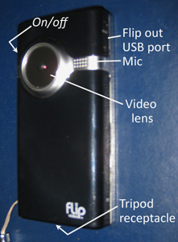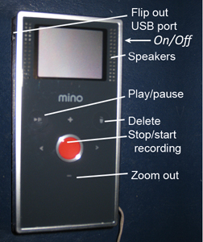

The controls are self-explanatory, but a few notes might be helpful. . .
• To turn on or off the camera, hold the On/Off button depressed until you hear a beep; then release
• When the camera is on, the screen will illuminate. The word “Ready” appears in the left upper corner when video is not being recorded. When the image is being recorded, the left upper corner displays the duration of the recording in minutes:seconds.

Be careful: it is easy to thinking you are recording when you are not!!
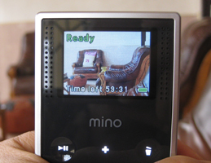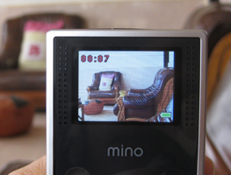
Not recording Recording

• This camera (and most other commercial camcorders) adjust the camera iris automatically to accommodate the amount of ambient light. A dark-skin individual placed in front of white or reflective surface may appear as a silhouette. To enhance their facial features, lighting from the side may be used for dramatic effect. Or better, placing them in front of an unlit and preferably non-reflective, non-white background will enhance the features of their face. Some of this can be corrected in the editing phase, but it is preferable to capture useful video at the outset.


white background same with sidelight yellow background

• The videos are downloaded and the camera battery is charged through the USB connection to your computer.
• The camera contains the software that you need to download your video files.

Downloading FLIP video to your computer:
When you insert the camera into the USB port, do not open autoplay and (for MAC users) close iPhoto. Open the Flip Video icon in the “Computer” window (PC) or on the desktop directory (MAC).

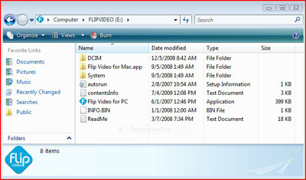
You will be asked to install “necessary software” onto your computer. Allow the installation, and wait until it is complete. Open “Flip Video for PC” or “Flip Video for Mac” (depending on your system).

After a graphic title screen comes and goes, the screen (below) will appear showing all of the videos on the camera and allowing you to preview them before downloading.
To save videos (in AVI format) to your computer, click on the “Save videos” button on the lower left. The next screen will allow you to click and highlight the videos that you wish to save. When you click the “Save to Computer” button for the first time, the program will create a folder within your “Documents” folder, entitled “My Flip Video Library.” It will also prompt for the name of a folder for the videos you are currently downloading. Or, you can select from among folders that you established in previous sessions.
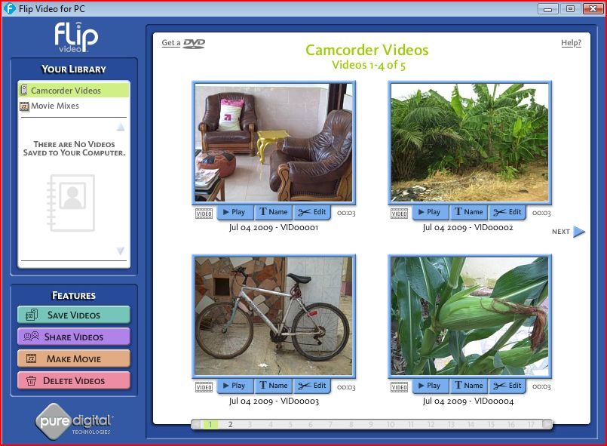

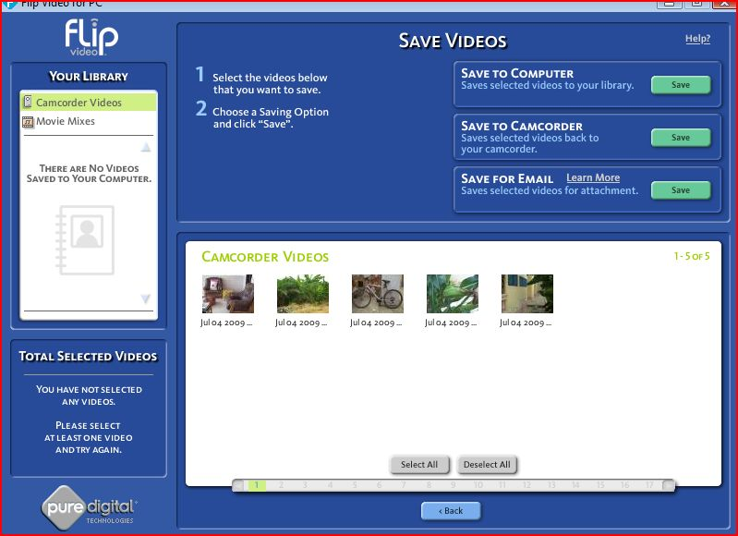

For most purposes, you will want to access your video files directly from the folder in “My Flip Video Library.” You will have to convert them to a different format in order to import them into Premiere Pro for editing.

[Activity: film and save a <15 second video with the FLIP camera. This brief clip will be used as an introduction to video project that you will do later.]

III. VIDEO AND AUDIO FILE FORMATS

Different media file formats are derived from different sources or are encoded for use on different computer platforms. The video and audio data are encoded and decoded with programs called CODECs, and some formats use different CODECs. So, for example, not every video that will play on your computer screen will play on your DVD player and TV.

Some common audio file types are:
.mp3 (commonly used in portable media players; audio input for flash videos)
.m4a .mp4 (used in iTunes and iPods)
.aiff (formatted for audio CD players)
.wav (a standard format for computer-based sounds in Windows; it can also be played by Quicktime)

Some common video file types (containers) are:
.mpg (MPEG-3, an industry-standard format for low resolution video)
.m4v, .mp4 (MPEG-4, designed for DVD players and video podcasts)
.wmv (a “Windows Media Video” format designed for the Windows Media Player; it usually must be converted to play with other media players)
.mov (Quicktime movie which can be viewed on all Macs and on PCs that have Quicktime for Windows installed)
.flv (“Flash video”. It does not play with most video players or on computers by itself. This is the most common video format used on the internet for streaming video (e.g., YouTube). It must be inserted into a Shockwave Flash file, .swf, to play on the web)
.avi (“Audio Video Interleave” -- a format used by cell phones, digital still cameras, and by the FLIP video camera)
.dv (“digital video.” This is raw video data without any formatting or compression. It is the output format of most camcorders)

Sometimes, video and audio editing programs include converters so that media in a variety of formats can be imported and manipulated.
For windows, a program called MediaCoder is open-source, free software. It can be used to convert .avi video files from the FLIP camera to equivalent .mov (for MAC) or .wmv or .flv (for PCs) files that can be rendered in PremierePro. The software can be downloaded from:
http://download.cnet.com/1770-20_4-0.html?query=mediacoder&tag=srch&searchtype=downloads&filterName=platform%3DWindows&filter=platform%3DWindows

For MAC, a media encoder called “EasyWMV” convert files of various formats to mp4 and mpg. A free version is available on-line, but the individual file lengths are limited to 1 minute. For longer continuous video conversions, a complete copy of the software is available for download for 15 dollars.

[Activity: Use Media Coder to convert the FLIP video file to a .flv file (PC) or a .mp4 file (MAC)]

PCs:
1. open Media Encoder
2. import Video from the Documents>My Flip Video Library folder. It should appear in the upper left window. You can check the file by clicking on the item and then clicking on the “play selected item” button (4th from the left on the top row)
3. adjust the following settings:
a. create an output file by clicking on the browse button under the “Generic” tab
b. set the video format to Flash video (under the “Video” tab)
c. set the audio encoder to LAME mp3 (under the “Audio” tab)
d. set the container to Flash Video (under the “Container” tab)
4. click the start button (farthest on the right at the top)
5. check the output file by clicking on the “play transcoded result” button (5th from the left in the top row.

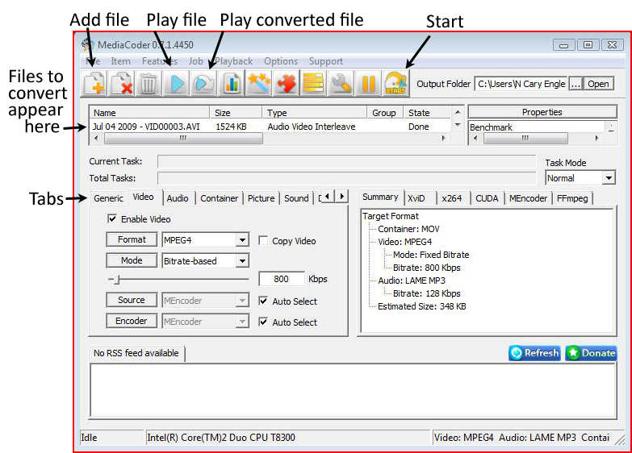

MAC:
1. Double-click on the “EasyWMV” icon to open the converter.
2. Click on the “inspector” to confirm that the format is set to mp4
3. Drag the icon of your .avi video file to the EasyWMV icon or to the open conversion window. The program will create a new .mp4 version of the file in the same folder with the original avi file.

