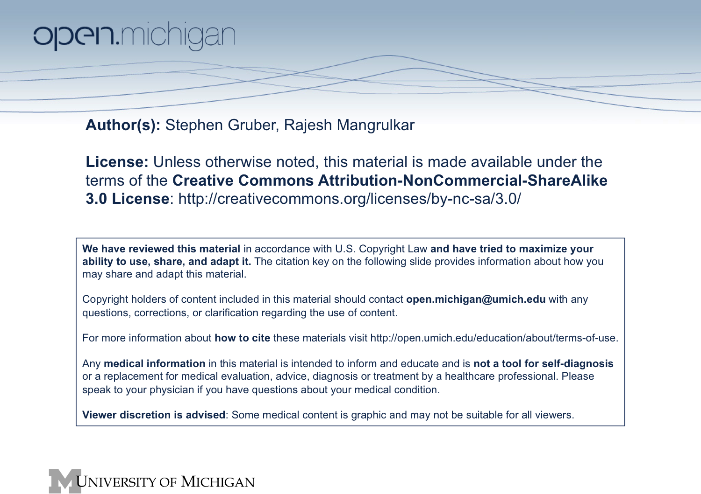

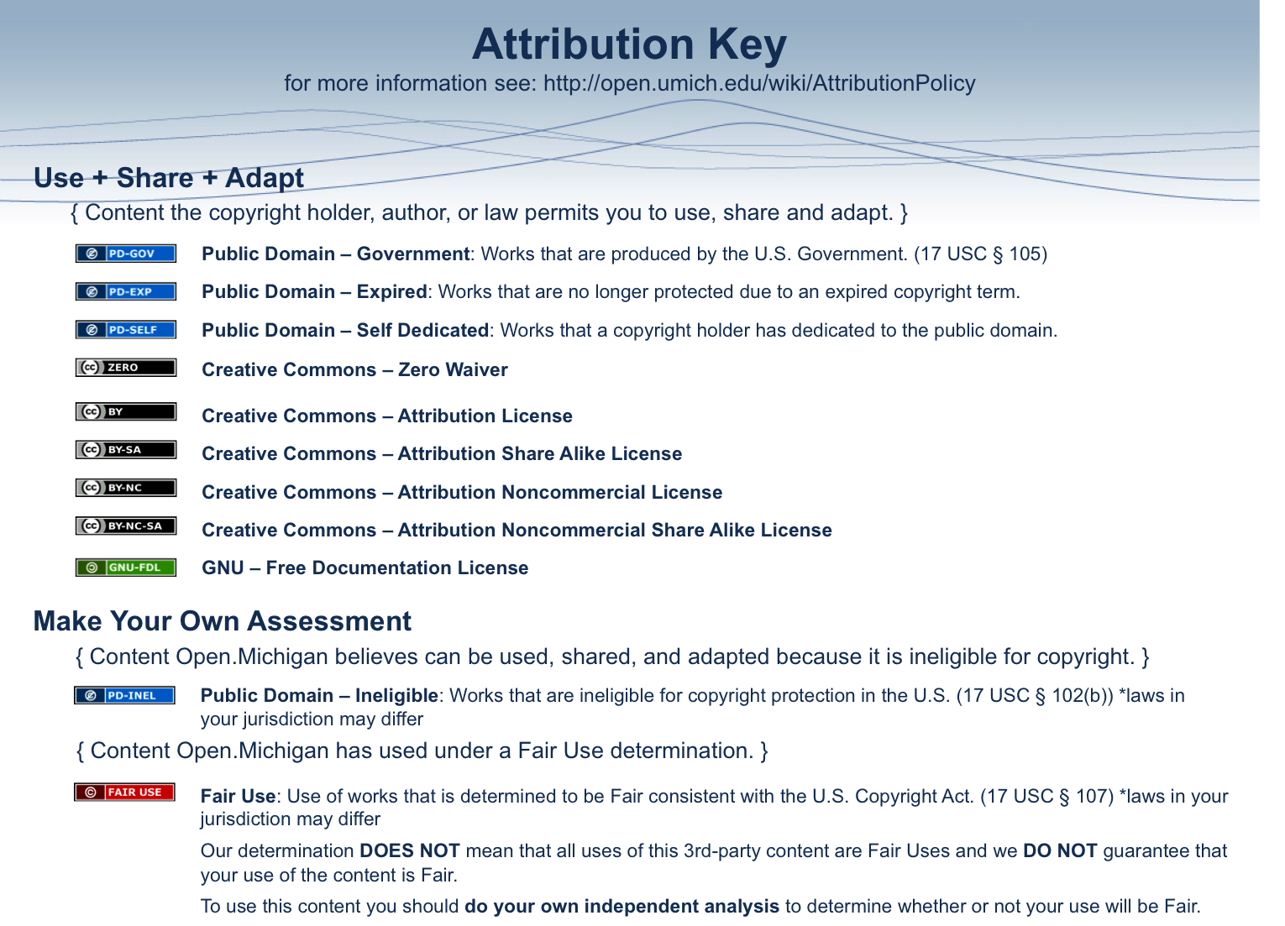

Medical Decision-Making Component Logistics

Schedule – Content – Readings/Assignments
Information Retrieval (Ask and Acquire) Thread

August 4  11 AM-12 Noon | Lecture (1 hour)  The Value of Uncertainty  - The decision-making context  - Differential Diagnoses  - Introduce Computer Session #1 Option and Assignment #1 | Readings:  Syllabus (required)  Background  The Questions  The Search: Basic Concepts  Articles – found in syllabus (required)  Chances Are (New York Times Reprint)  Slaying of a Beautiful Hypothesis by Facts  Users’ Guides (strongly recommended) – The MANUAL  Chapters 1-4 (pages 3-58)  User’s Guides (optional) – The ESSENTIALS  Chapters 1-4 (pages 1-76)  Assignment (required)  Assignment #1–turn in at Computer Session #2
August 8  9-10 AM | Lecture (1 hour)  The Information Cycle  - Probability Laws, Bayes Probabilistic Reasoning  - Question-Generation  - Targeting information resources
August 5  1:30-2:30, 2:30-3:30, 3:30-4:30, or 4:30-5:30 PM | Computer session #1 (1 hour) – OPTIONAL  Introduction to the Information Resource Environment  - Overview of Environment  - Question generation - Apply MDM principles to MDC-Down Syndrome session (August 6, 1-3 PM)  - Introduction to PubMed and OVID
August 19 1-3 PM or Aug 22 3-5 PM or August 23  1-3 PM or 3-5 PM | Computer session #2 (2 hours) - MANDATORY  Basic and Advanced MEDLINE Searching  - Review and Collect Assignment #1  - PUBMED / OVID distinctions  Introduction to Longitudinal Cases Resources  - Advanced background resources  - Psychosocial literature databases  You are the Filter

Biostatistics and Clinical Epidemiology (Appraise) Thread

August 5  9AM-10 AM  August 8  1PM-2PM | Lecture (1 hour)  Introduction to Biostatistics  - Hypothesis generation and testing  - Sampling  - Statistical testing  - Statistical significance vs. Clinical Significance  - Confidence Intervals | Readings:  Syllabus (required)  Fundamentals of Epidemiology and  Biostatistics  Users’ Guides (strongly recommended) – The MANUAL  Chapter 5 (pages 59-64)  Chapter 10.1 (partial) (Pages 209-215)  Chapter 10.2 (pages 221-229)  Chapter 12 (pages 363-381)  Chapter 18 (pages 509-520)  User’s Guides – The ESSENTIALS (optional)  Chapter 5 (pages 77-84)  Chapter 9 (pages 141-168)  Chapter 13 (pages 223-238)  Assignments (required)  Assignment #2 – turn in at Small Group Session #1
August 9  11AM-12 Noon  and  1-2 PM | Lectures (2 hours total)  Observational Studies, Biostatistics and Epidemiology  - Confounding  - Cohort studies  - Case-control studies  - Cross-sectional studies  - Introduce Assignment #2 (covers lectures)
August 11  1-3 PM  or  3-5 PM | Small Group session #1 (2 hours)  Observational Studies and Basic Biostatistics  - Review and Collect Assignment #2  - Apply principles from lectures to problem sets and cases

Diagnostic Reasoning (Apply) Thread

August 15  9-10 AM  and  10-11 AM | Lectures (2 hours)  Diagnostic Reasoning-I and II  - Prevalence/Incidence  - Sensitivity / Specificity / Accuracy / Precision / Likelihood Ratios / Predictive Values  - Diagnostic Question Generation  - Gold standards and blinded-assessment  - Probabilistic Application  - Introduce Assignment #3 (covers lectures) | Readings:  Syllabus (required)  Fundamentals of Diagnostic Interpretation  Article (required)  Mammogram Math (NY Times reprint)  Users’ Guides (strongly recommended) – The MANUAL  Chapters 15-16 (pages 407-438)  Chapter 17.4 (pages 491-505)  User’s Guides – The ESSENTIALS (optional)  Chapters 11-12 (pages 179-222)  Assignments (required)  Assignment #3 – turn in at Small Group Session #2  Assignment #4 – turn in at Small Group Session #3
August 16  1-3 PM  or  3-5 PM | Small Group session #2 (2 hours)  Diagnostic Reasoning  - Review and Collect Assignment #3  - Apply principles from lectures to problem sets and cases  - Receiver Operator Characteristic Curves (ROC)  - Introduce Assignment #4 (Covers MDC Colon Cancer)
August 24  3-4 PM  or  4-5 PM | Small Group session #3 (1 hour)  Diagnostic Reasoning Applied to Colon Cancer  - Apply MDM principles to MDC-Colon Cancer session (August 25 1-3 PM)  - Review and Collect Assignment #4

