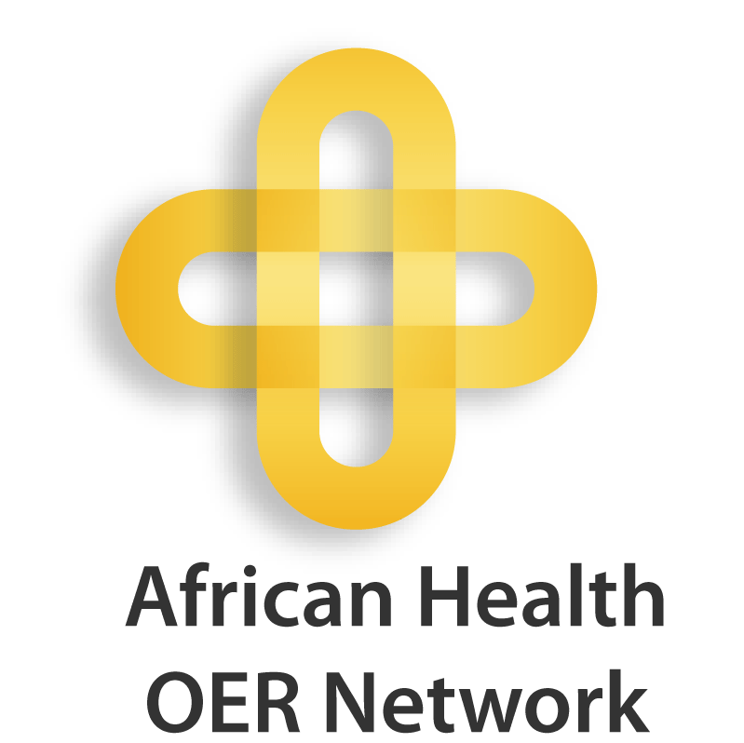

Request Facility: A Reference Service for Finding OER for Targeted Health Training

Looking for heath educational materials to supplement your teaching, research, or professional development?

If you would like support in locating existing, relevant OER, you can complete and return this form. If you or someone from your staff are comfortable searching on your own, we encourage you to consult these websites: http://www.oerafrica.org/healthoer/FindOER/tabid/1862/Default.aspx, http://open.umich.edu/share/use, https://open.umich.edu/wiki/Open_Content_Search#Medical.

Email a copy of the completed form(s) to healthoer@oerafrica.org. The request and responses will be posted at http://openmi.ch/request-health-OER.

An asterisk (*) indicates a required field.

Contact Information
Contact information will not be made public and will only be shared with the African Health OER Network Communications Team.

Name:*
Surname:*
Institution:*
E-mail address:*
Primary Telephone:
Country*
Department or Discipline*

Request for Openly Licensed Educational Materials

Name of course or programme for which would you like the material*

Learning objectives for the course or programme

Suggested topics or keywords related to this topic*

Web address (URL) or attachment containing further information, such as a course syllabus or curriculum outline

Intended Learner Audience*
Undergraduate
Postgraduate/Graduate
Continuing or Professional Education
Other

Types of materials desired (e.g. courses, case studies, lab exercises, lecture presentations, videos, data sets, textbooks, software application)*

Additional comments that would aid our search:

