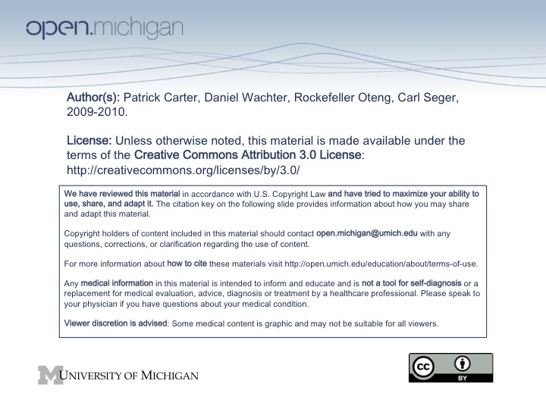
Advanced Emergency Trauma Course (AETC)
Course Schedule
Patrick Carter, M.D.

Day 1:
- Didactic Lectures – 8 am to 1 pm
- Introduction and Course Interview (1 hour) – Patrick Carter, MD
- Initial Assessment and Management (1 hour) – Patrick Carter
- Airway and Ventilation Management (2 hours) – Daniel Wachter, MD (Patrick Carter)
- Shock (1 hour) – Carl Seger, MD
- Lunch – 1 pm to 2 pm
- Skill Stations – 2 pm to 5 pm
- Basic Airway Maneuvers (Bag-Valve Mask, OP Airway, NP Airway)
- Orotracheal and Nasotracheal Intubation
- Difficulty Airway Station (LMA, Bougie, Fiber-optic Intubation, Retrograde Intubation)
- Surgical Airway Station
- Trauma Scenario Practice Station

Day 2:
- Didactic Lectures – 8 am to 1 pm
- Thoracic Trauma (1 hours) – Patrick Carter, MD
- Abdominal and Pelvic Trauma (1 hour) – Daniel Wachter, MD (Rocky Oteng)
- Genitourinary Trauma (1 hour) – Daniel Wachter, MD (Rocky Oteng)
- Head Injury (1 hour) – Patrick Carter, MD
- Cervical and Spinal Cord Injuries (1 hour) – Carl Seger, MD
- Lunch – 1 pm to 2 pm
- Skill Stations – 2 pm to 5 pm
- Tube Thoracostomy/Pericardiocentesis Station
- Central Venous Access Station (Central Line, Venous Cutdown)
- Thoracotomy Station
- Intraosseous Line Placement
- Radiograph Review (Thoracic, Abdominal/Pelvic Trauma, Head Injury)
- Trauma Scenario Practice Station

Day 3:
- Didactic Lectures – 8 am to 1 pm
- Maxillofacial Trauma (1 hour) – Carl Seger, MD
- Penetrating and Blunt Neck Trauma (1 hour) – Rockefeller Oteng, MD
- Orthopedic and Extremity Trauma (2 hours) – Patrick Carter, MD
- Burn Evaluation and Management (1 hour) – Carl Seger, MD
- Lunch 1 pm to 2 pm
- Skill Stations – 2 pm to 5 pm
- Cervical and Spinal Immobilization
- Splinting workshop
- Radiograph Review (C-spine Injury, Orthopedic Injuries)
- Trauma Scenario Practice Station

Day 4:
- Didactic Lectures – 8 am to 1 pm
- Environmental Injuries (1 hour) – Carl Seger, MD
- Ballistics and Penetrating Extremity Injuries (1 hour) – Carl Seger, MD
- Wound Care (1 hour) – Rockefeller Oteng, MD
- Special Populations: Pregnancy, Pediatrics, Geriatrics (1 hour) – Rockefeller Oteng, MD
- Pre-hospital Management/Transfer to Definitive Care (1 hour) – Rockefeller Oteng, MD
- Lunch – 1 pm to 2 pm
- Skill Stations – 2 pm to 5 pm
- Wound Care Workshop
- FAST Exam Station
- Trauma Scenario Practice Session

Day 5:
- Review of Course Material for Examination – 8 am to Noon
  - Rapid Review of Key Facts
  - Trauma Scenario Practice Session
- OSCE/Written Test Evaluation – 1 pm to 4:45 pm
  - OSCE
  - Written Test
- Post-Course Survey (4:45 to 5 pm)

