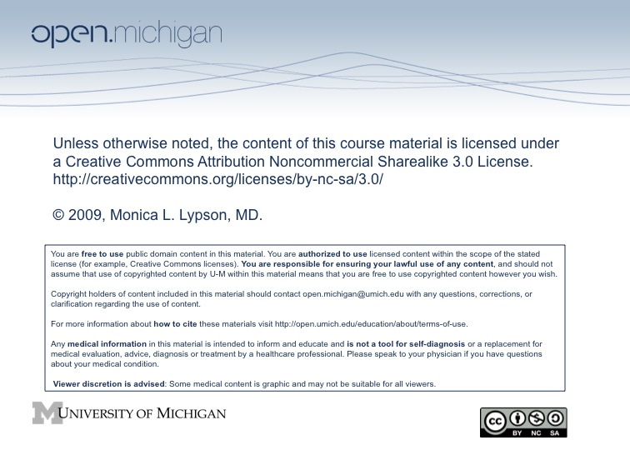

Using Multimedia in Faculty Development on
Multicultural Education:
Scenes from the Movie
crash

Session Overview & Format:
This is a FACULTY DEVELOPMENT WORKSHOP. This workshop is designed to last approximately 1.5 hours and will assist faculty in facilitating discussions on race, gender, sexual orientation and socioeconomic diversity. Upon viewing four different scenes from the Academy Award-winning movie Crash, participants will engage in active discussion sessions in which they reflect on their impressions of the actors, situations and themes of each scene. They will be asked to discuss the contentious and emotional issues that had created the situation in each scene as the basis for exploration of their own personal and professional experiences and identities. This workshop provide faculty with skills to use when discussing controversial issues with their students.
Crash
http://www.imdb.com/title/tt0375679/
The 2004 film, winner of 3 Academy Awards, is about the
Inter-twining racial and social tensions in Los Angeles.

Intended Learning Outcomes
- To improve awareness of issues related to teaching in a multicultural classroom.

- To expose faculty to the use of multimedia (narrative/stories) to stimulate discussion on topics of diversity.

- To improve small group facilitation skills on topics of multiculturalism.

- To explore issues of privilege/racism/class in U.S. society.

Crash Workshop
AGENDA

Introductions |  |  | 5 mins
Overview of Intended Learning Outcomes (ILOs) & Ideals of Group Interactions |  |  | 5 mins
ACTIVITIES
Scene 1 | Large Group Exercise |  | 10 mins
Scene 2 | Using Reflective Writing |  | 15 mins
Scene 3 | Small Group Interactions |  | 20 mins
Scene 4 | Using the "Fishbowl" Technique |  | 30 mins
Wrap Up & Evaluation |  |  | 10 mins

SCENE 1

Title:
Pawn Shop/Attempted Shooting (10 minutes)

Session Format:
Open discussion

Process:
- Reflections on the scenes
- Large Group Discussion

Topics:
Language barriers, immigrant stereotyping, victim becoming the victimized

Questions for Reflection:
- How did you FEEL about these scenes?
- Did the scene pairing impact your views on the characters?
- How would you deal with a group of students with similar feelings around the issues portrayed in the movie?
SCENE 2

Title:
Blind Fear/Freeing the Slaves (15 minutes)

Session Format:
Reflective Writing

Process:
- Spend three (3) minutes writing down reflections especially focused on the affective domain (feelings evoked by these scenes).
- Discuss your reflections in small groups of three

Topics:
Generalizations, stereotypes, intra-group profiling, racism

Questions for Small Group:
- Make a list of the three most striking themes that arise from this pair of scenes and come back and share with large group.
- What is the connection between these two scenes?
- How would one use reflective exercises as this one to promote student learning around difficult issues?

SCENE 2

Title:
Blind Fear/Freeing the Slaves

Describe in several sentences your reflections on the issues portrayed in these scenes. Continue to focus on the affective domain.

List the three most striking themes that arise from this pair of scenes below.

1.
2.
3.

What is the connection between these two scenes?

SCENE 3

Title:
Telephone Conversation/Meeting with Insurance Manager/Car Crash
(20 minutes)

Session Format:
Small group interactions

Process:
Discuss your reflections in small groups of three

Topics for your consideration:
- Assumptions, profiling, privilege, Affirmative Action

Questions for consideration:
- What themes appear in these scenes?
- How are the issues of position and privilege reflected in these scenes?
- As an instructor dealing with these themes and your own emotions, how do you facilitate a discussion these topics in the classroom setting?
- How would you (Primary Care Provider) react at the next visit if the father was your patient and you had refused referral to the specialist?
- How would you help students reflect on the themes as they relate to health care reform?
SCENE 4

Title:
First Traffic Stop/Bedroom Conversation/Second Traffic Stop (30 minutes)

Session Format:
Fishbowl

Process:
Fishbowl (gender-based groups)
- Watching Scenes & Fishbowl Explanation (5 minutes)
  - Arrange chairs in two concentric circles
  - Explain the activity to learners, those on the outer circle will remain silent and observe (men)
  - The learners in each group must use active listening skills and find ways to discuss difficult issues
- Inside Group Response (10 minutes)
  - The inner circle will reflect on the questions posed to the group (women)
- Outside Group Response (15 minutes)
  - Once the conversation comes to a close, the outer group will be asked to weigh in on the discussion

Topics:
Profiling, (dis)empowerment, sexism, racism

Questions for consideration:
- What is the process you are observing?
- Can you relate this to any previous experience you may have had?
- How did you feel about this scene?
- How could you use the lessons learned from this activity and this segment of the movie to assist you in teaching in your small groups?
- How have the comments you heard inform you about some of the feelings your students may have?

FISHBOWL DESCRIPTION

The fishbowl is a very strong peer learning strategy in which some participants are in an outer circle and one or more are in the center of the outer circle. In all fishbowl activities, both those in the inner and those in the outer circles have roles to fulfill. Fishbowls can be used to assess comprehension, as described in the Hot Seat variation below, to assess group work, to encourage constructive peer assessment, to discuss issues in the classroom, and to do a number of other things. Consider the activity and use it when you feel it is appropriate to meet your needs.

In its simplest form, arrange chairs in the classroom in two concentric circles. Explain the activity to the learners and ensure that they understand the roles they will play. Make sure all learners are seated in both the inside and the outside at some point, though they don’t all have to be in both every time you do a fishbowl activity. Normally, either the person or people in the inner circle interact while those in the outer circle observe – with a list of specific aspects of the interaction to observe, or, the person or people in the inner circle are, in a sense, in the hot seat, being asked questions by those in the outer circle. An example of the latter is below in the Hot Seat activity. An example of the former follows.

Because group work can sometimes be a struggle, as learners begin to engage in group projects, they are learning both the content for the project and how to act and participate in groups. One way to have learners think about how people work best in groups is to create a fishbowl in which one group is in the fishbowl – or in the center circle. Before you begin, each of the learners in the fishbowl has to be clear of his or her role in the group. Each of the learners outside the fishbowl, or in the outer circle, has to be clear of what he or she is observing. You can do this however you think it will work best for your learners. One idea is to have each student in the outer circle observing one student in the inner circle (you may have to double, triple, or quadruple up, but that’s a good thing). Another way of doing this is to give each learner in the outer circle a list of aspects of group interaction they should observe and comment on.
The most important thing is to remind all learners that they will all be in the fishbowl at some point, so they have to keep in mind how they state their observations and criticisms. This does not mean that they shouldn’t say things that are hard to say or hard to hear, just that they should say them in polite, constructive ways, rather than with the intention of hurting someone.
Reference:
More information can be found at eSubjects.com under curricular supplements
SCENE EXCERPTS*

Below are guidelines for creating your own excerpts from the 2004 DVD Crash.

SCENE 1
Pawn Shop/Attempted Shooting
- 6:00–7:47
- 1:20:35–1:22:02

SCENE 2
Blind Fear/Freeing the Slaves
- 7:48–10:00
- 1:45:19–1:46:56

SCENE 3
Telephone Conversation/Meeting with Insurance Manager
- 15:32–16:14
- 46:24–49:07

SCENE 4
First Traffic Stop/Bedroom conversation/Second Traffic Stop
- 17:17–22:24
- 23:15–25:05
- 1:14:29–1:18:33

*We recommend having all workshop participants view the movie in its entirety prior to attending the workshop. It is not critical, but helpful.
REFERENCES

Kinefuchi, E. and Orbe, M. 2008. Situating Oneself in a Racialized World: Understanding Student Reactions to Crash through Standpoint Theory and Context-Positionality Frames. Journal of International Intercultural Communication, 1:1:70-90.

Vallalba, J.A. and Redmond, R.E. 2008 . Crash: Using a Popular Film as a Experiential Learning Activity in a Multicultural Counseling Course. Counselor Education & Supervision, 47:264-276.

Kumagai, A.K. and Lypson, M.L. 2009. Beyond Cultural Competence: Critical Consciousness, Social Justice, and Multicultural Education. Academic Medicine, 84(6):782-787.

Reilling, J.M., Ring J. and Duke, L. 2005. Visual Thinking Strategies: A New Role for Art in Medical Education. Family Medicine, 37(4): 250-252.

Kumagai, A.K., White, C.B., Ross, P.T., Perlman, R.L., Fantone, J.C. 2008. Impact of Facilitation of Small Group Discussions of Psychosocial Topics in Medicine on Faculty Growth and Development. Academic Medicine, 83(10):976-81.

Gorski, P., Culture Exercise. 2009. Found at YouthWebOnline.com under teacher activities - culture. Accessed September 21, 2009.

16X9 Widescreen 2:35:1 DVD Screen Format Catalog # 17938

