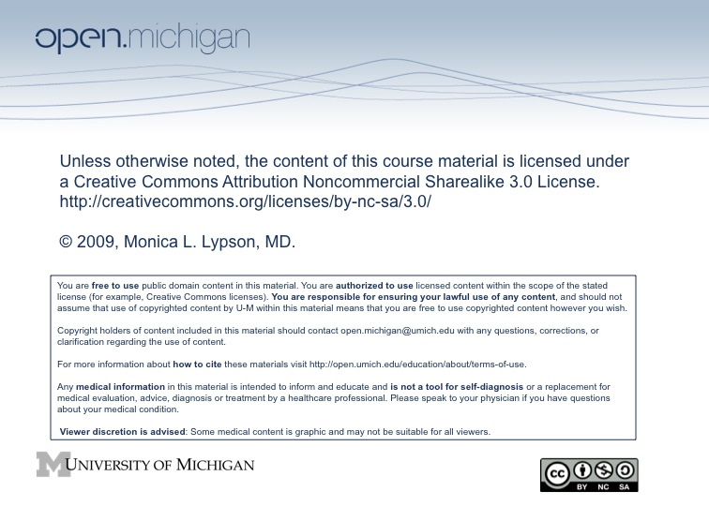

Workshop Evaluation (Page 1)
Name/Email:_____________________________________ (Optional)
ITEMS | Strongly Agree  5 | Agree  4 | Neither Agree / Disagree  3 | Disagree  2 | Strongly Disagree  1
- The scenes from the movie Crash helped me to reflect on my own attitudes toward race and diversity.
- The discussion of the movie Crash helped me to reflect on my own attitudes toward race and diversity.
- I am comfortable using conflict in classroom discussions to stimulate productive discussions on issues of race.
- I am reluctant to discuss issues of race in class because of possible conflicts which may arise.
- I think conflict between racial/ethnic groups makes it difficult for them to communicate with each other.
- I believe that it is more important for small group members to get along than to challenge each other’s beliefs.
- Being confronted with unfamiliar perspectives and situations helped me to reflect on issues of race and diversity in U.S. society.
- Disagreements in classroom discussions make me uncomfortable.
- I believe this workshop will help me to better understand the perspectives of my students.

Please read the following scenario and answer Questions 11-14.
Suppose a small group discussion on race-based health care disparities escalates into a heated argument between students.
ITEMS | Strongly Agree  5 | Agree  4 | Neither Agree / Disagree  3 | Disagree  2 | Strongly Disagree  1
- I would ask the students to continue the conversation, but in a more respectful manner.
- I would immediately discontinue class/conversation to allow the students a chance to cool down.
- I would use a personal experience to get the students to understand a different perspective

Workshop Eval. (Page 2) Name/Email:___________________________________________

- What was, for you, the most important things you learned from the movie?

- How did the movie change your views on race (if at all)?

- What was, for you, the most important things you learned from the workshop?

- How did the workshop change your views on race (if at all)?

- What aspects of the workshop would you like to incorporate into your facilitation of discussions of diversity?

- Suggestions for improvement for the workshop.

- What are your thoughts on the use of movies or other visual media in medical education for the purpose of discussing highly divisive issues?

