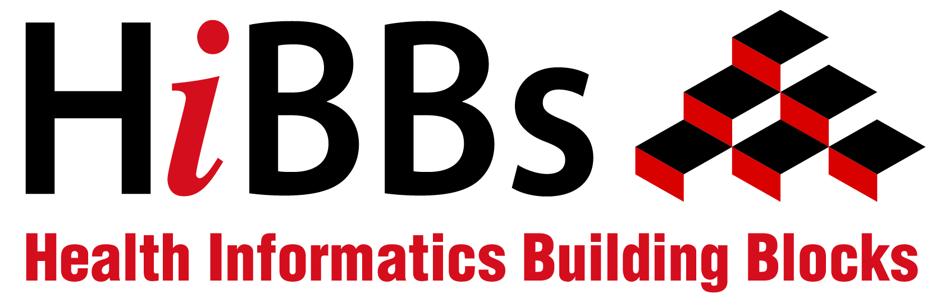
HIBBs Detailed Specifications
- Identifier (system generated):
- Title: Introduction to Computers
- Creators/Contributors: Callie Archibald and Kristen Zwick, Indiana University-Purdue University-Indianapolis (IUPUI), School of Informatics students in Computing for a Cause course
- Content Creation Date: 2011
- Publisher: GHIP
- HIBB Repository Publication Date (system generated): July 2011
- Financial Support for Development of HIBB Provided by: Not applicable
- Language of HIBB: English
- Topic Area: Fundamental Skills
- Subject:
1. Introductory use of computers
2. Physical components of computers
3. Basic knowledge of how to use and interact with a computer
- Description of HIBB:
This HIBB first covers the physical components of a computer and their usage, such as keyboards, monitors, and USB cables. It also includes how to use some of these physical components, such as moving a mouse and how to insert a CD. It then moves on to basic interactions with a computer, including logging in, opening programs, and saving files.
- Learning Objectives:
At the end of this HIBB, students will be aware of the major physical components of a computer. In addition to this, students will be able to perform some basic functions on the computer, including logging in to the computer, opening programs, saving files.
- Keywords Describing HIBB:
1. Computers
2. Hardware components
3. Basic computer functions
4. Peripheral devices
- Intended Audience: This HIBB is intended for people who have never used a computer before or who have very little knowledge of computers and how to use them.
- Competencies/Skills that HIBB Addresses
Identifying the physical components of a computer
Using a computer including opening programs and files and saving files
Connecting devices to a computer including a printer and speakers
- Related HIBB(s). Indicate whether this HIBB is:
- Adaptation of an existing HIBB: indicate title and ID#:
- Translation of an existing HIBB: indicate title and ID#:
- Part of a series:
- Not applicable:
- Level of Computer/Health Informatics Knowledge Needed to Understand Content of HIBB:
- Novice: “I have never done this”
- Advanced beginner: “I have done this a little”
- Competent: “I am good at this”
- Proficient: “I could teach this”

18. Format of HIBB Components.
Table 1: HIBB Components and Files
Component Type | File Name | Type of File | Size of File | Duration/length of component
Slides Only | Intro_to_Computers_HIBBS_PowerPoint.ppt | Microsoft PowerPoint | 4.85 MB | 44 slides
Audio Only | HIBBS_FullLecture_audio.mp3 | MP3 audio only | 14.4MB | 15:46 minutes
Video | Intro_to_Computers_HIBBS.exe | Application | 33.8 MB | 52 slides
Transcript Only | Script_for_Introduction_to_Computers.doc | Microsoft Word | 67.5 KB | 5 pages
Supplemental Material | glossary_of_terms.doc | Microsoft Word | 28.0 KB | 1 page
Spec Sheet | Intro to Computers_spec sheet | Microsoft Word | 921 KB | 3 pages

19. Use of HIBB Content in Prior Training. Provide the following information about the HIBB:
- Training venue(s): NA
- Type of training: NA
- Year most recently offered in training: NA
- Number of times offered in training: NA
- Approximate number of individuals trained: NA
- Type of individuals trained: NA
- Content not used before: NA

