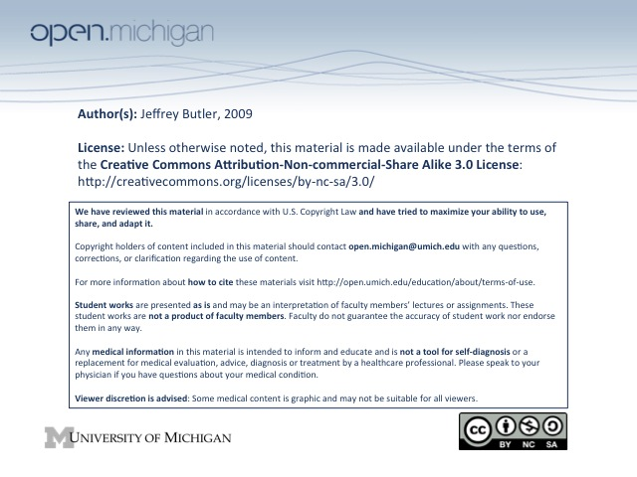
Cartilage
- Be able to recognize the three major cartilage types in typical light microscopic sections
  - hyaline – type II collagen found on articular surfaces, epiphyseal plates, tracheal wall, etc; most common type, clearly defined perichondrial, chondroblastic, chondrocytic layers
    - articular cartilage a specialized form of hyaline, differences are that chondrocytes are arranged vertically and have little or no mitotic activity, perichondrium is also absent, collagen fibers (not visible) arranged as gothic arches for support
  - elastic – type II collagen and elastic fibers, found on pinna of the ear, epiglottis, eustachian tube, etc; key identifying feature will be prevalence of elastin fibers and fewer isogenous groups
  - fibrocartilage – Type I and II cartilage, found in intervertebral disks, pubic symphysis, insertion sites of tendons and ligaments; no perichondrium, obvious fibrous matrix
- Be able to use standard nomenclature to describe a section of cartilage (e.g. chondrocyte, lacuna, matrix, perichondrium)
  - structure usually begins with pluripotent perichondrium giving rise to chondroblasts which develop to become chondrocytes once they begin secreting matrix; chondrocytes may mitotically divide to form isogenous groups; space in which chondrocytes sit called lacuna
  - dense territorial matrix immediately surrounds chondrocytes; less dense interterritorial matrix between chondrocytes and isogenous groups
- Understand the molecular basis for resilience of cartilages
  - matrix composed of collagen, hyaluronan, and proteoglycans to form weight-bearing network; synthesized by chondrocytes (except intervertebral disks where its not clear whether chondrocytes or fibroblasts responsible for secreting matrix)
  - dense negative charges of proteoglycan aggregates (axial hyaluronan, core proteins, and attached glycosaminoglycans like keratin and chondroitin sulfate) attract positive charges which suck water into the matrix to create a compression resistant gel
- Be able to describe the process of chondrogenesis
  - cartilage undergoes both appositional and interstitial growth
    - appositional from perichondrial differentiation
    - interstitial from chondrocyte mitosis
- with age the proteoglycans produced are smaller with shorter chondroitin sulfate chains, probably attracting less water and making cartilage less resistant to compression, results in less densely staining matrix

Mature Bone
- Be able to use standard nomenclature to describe the microscopic structure of bone (e.g. lamella, osteon, osteocytes, canaliculi, periosteum, endosteum)
  - osteon (Haversian system) is basic unit of bone. Haversian canal at the center in which capillary found, with transverse processes called Volkmann's canals to connect longitudinal Haversian canals, osteocytes present as stained dots embedded in lamella of osteon, space occupied by osteocytes defined as lacuna (as with cartilage) and processes that connect osteocytes called canaliculi
  - osteocyte processes connected by gap junction
  - periosteum is outer multilayered (fibrous and cellular) lining of bone, endosteum is inner lining
  - osteoblasts and osteoclasts only found on surface where remodeling occurs, osteocytes embedded in matrix, osteoclasts form Howship's lacuna from bone resorption
  - bone composition
    - 25% water content
    - cells: osteoblasts, osteocytes, osteoclasts
    - fibers: type I collagen (90% of organic content)
    - bone matrix: ground substance (GAGs), hydroxyapatite [Ca10(PO4)6(OH)2]
- Be able to recognize mature bone (dense and cancellous) in conventional or ground section. Be able to identify the component parts of mature bone (e.g. osteon, lamella, lacuna, osteocyte) in appropriate sections
  - pretty obvious, if you have a mental picture of definitions above you'll probably be fine
- Be able to describe the anatomical route that nutrients and metabolic products use between the vascular system and osteocyte
  - see description of haversian canals, volkmans canals, and canaliculi

