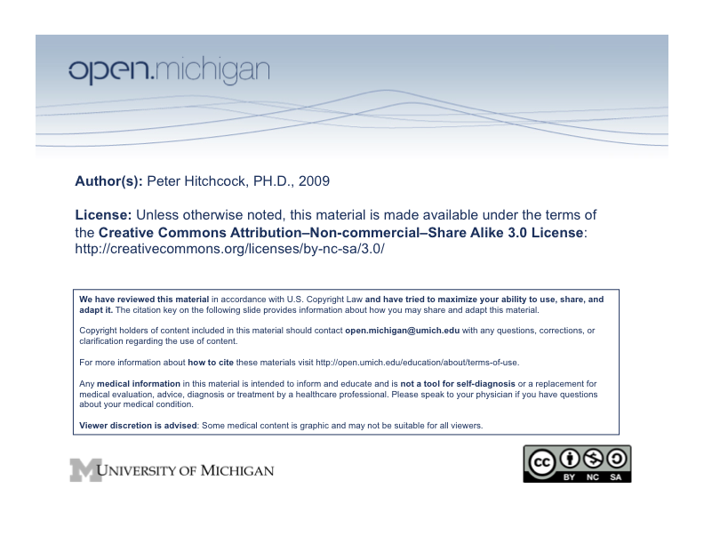

Intended Learning Outcomes

The Neuroscience Sequence is foundational in nature and stresses the organizational principles and structure/function relationships in the central nervous system. The course emphasizes the relationship between the gross organization of the CNS, its subdivision into specialized regions and the corresponding perceptions of sensory information and the nervous system control of behavior. The cell biology of the neuron, neurotransmitter systems and neuronal injury and repair are also emphasized.

It is intended that upon completion of this sequence students know and understand both the external and internal anatomy of the central nervous system, including the clinically relevant sensory and motor pathways. In addition, students will know the histology and cell biology of neurons and some molecular details of neurotransmitters and synaptic communication. Students will know the anatomy of the cranium and vascular supply to the brain as well as the histology of neurons and the special sensory organs, eye and ear.

Sequence Information

Sequence Examination and Grading

Performance will be assessed by two Friday quizzes and a comprehensive final examination. The quizzes on Friday, March 13 and 20, will be all done online and will be multiple choice questions. Each quiz will cover material up to and including Friday’s lectures. The final exam will include both written and practical portions. The written portion will be available on Friday, March 27 @ 5:00 PM. The examinations for gross anatomy and neuroanatomy will include practicals and will be conducted on Friday afternoon, March 27. The number of exam questions will be approximately proportional to the time allocated for lectures and laboratory hours. All exam questions weigh equally and are worth 1 point. To pass the sequence, students must achieve a minimum score of 75% on the quizzes and final exam as usual, and fulfill the requirements of the longitudinal case small groups.

Texts
In addition to the texts that you have used throughout the year in previous sequences, there is an additional, recommended text:
Martin, John H. Neuroanatomy: Text & Atlas, Appleton & Lange, 3rd edition, 2003, ISBN: 007138183X

Lecturers: Normal CNS, Special Senses, Head & Neck

Peter Hitchcock, Ph.D. – Course Director
Department of Ophthalmology and Visual Sciences

Richard Altschuler, Ph.D.
Department of Otolaryngology, Kresge Hearing Research Institute

Michael Hortsch, Ph.D.
Department of Cell & Developmental Biology

W. Michael King, Ph.D.
Department of Otolaryngology, Kresge Hearing Research Institute

Jonathan Maybaum, Ph.D.
Department of Pharmacology

Erica Schuyler, M.D.
Department of Neurology

Audrey Seasholtz, Ph.D.
Mental Health Research Institute, Department of Biological Chemistry

Kelli Sullivan, Ph.D.
Department of Neurology

J. Matthew Velkey, Ph.D.
Department of Cell & Developmental Biology

Staff Support-Office of Medical Education
Sara Weir

