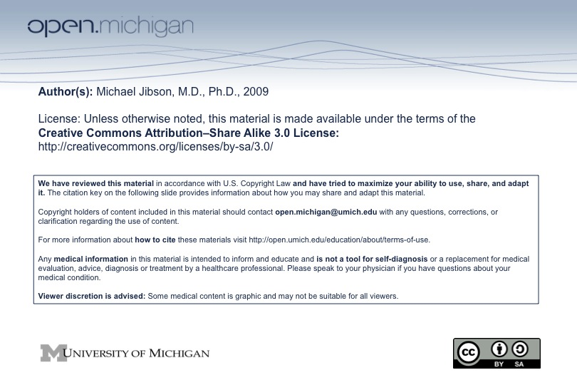
Psychiatry Sequence 2008-09

Course Description

The purpose of this course is to introduce students to clinical psychiatry. The course will focus on the clinical diagnosis and treatment of psychiatric disorders, with those elements of neurobiology, behavioral science, and pharmacology that are essential to the understanding of these disorders. The specific goals for students are:

- To learn the nomenclature and classification system used in the description of psychiatric symptoms and disorders.

- To learn the symptoms, etiology, epidemiology, neuropathology, and treatments for each of the major psychiatric disorders.

- To diagnose the major disorders on the basis of clinical presentation.

- To become familiar with the medications and psychotherapies used to treat psychiatric disorders.

Teaching Methods

The lecture series includes 22 hrs of didactics. A syllabus will be provided with the majority of material for which students will be responsible. Most slides and lectures will be available on the CTools portal.

A small group experience with a live patient interview highlighting the clinical presentation and mental status examination of a psychiatric disorder will occur in University Hospital on the afternoons of October 29 and 30. You will be assigned to one afternoon. Attendance at the small group session is required. Although professional attire is expected, this need not include white coats.

In the RARE circumstance in which you cannot attend, you must contact your class counselor in advance (or as soon as possible in an emergency) to request a deferral. (Please do NOT contact the sequence director with a request for or explanation of deferral.) Absences will be approved or denied by class counselors based on the same guidelines used for Quiz and Exam deferrals. Should you obtain a deferral from your class counselor, contact the course coordinator for make-up instructions for the small group experience.

Optional material on Complimentary and Alternative Medicine is included on the Portal. This information is for enrichment and will NOT be covered on the final examination.

Additional supplementary learning materials will be available on the Portal. These materials are intended to facilitate and broaden your understanding of the core materials found in the syllabus. You are not responsible for this optional material.

Textbooks and Reading Material

The recommended text for the sequence is Andreasen & Black, Introductory Textbook of Psychiatry, 3rd ed. Pharmacology lectures refer to Goodman & Gilman’s The Pharmacological basis of therapeutics, 11th ed. Other recommended or alternative readings may be provided by lecturers. None of the readings is required and no examination questions will be taken exclusively from the readings.

Examinations and Grading

Grades will be determined by a written, multiple-choice (computer based) final examination. Attendance at the Mental Status Examination (MSE) small group experience is required.

Grading will follow guidelines established by the Component II Directors and Sequence Coordinators as follows:

- Pass: 75-100%
- Fail: 74.999% and below

Sequence Coordinator

Michael D. Jibson, M.D., Ph.D., Department of Psychiatry.

