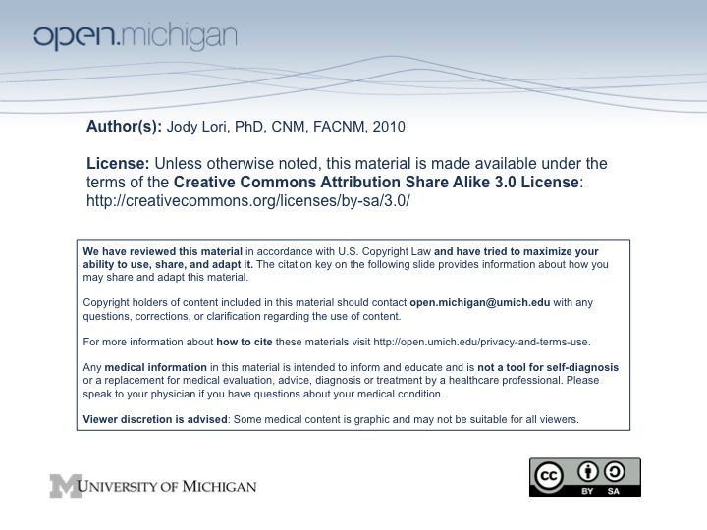

University of Michigan
School of Nursing
N420/WS432

Millennium Development Goals Discussion: Each student group will lead the class in a facilitated discussion on one of the Millennium Development Goals (MDG). It is expected that the facilitation group will have spent additional time analyzing the readings and be prepared to both guide the discussion and answer questions. Each facilitation group will have approximately 50 minutes of class time. Facilitation may include writing discussion questions and/or planning small group activities. The discussion leaders will present background on the specific MDG, what has been done to date toward achieving the goal, including the impact of the advances in science, economics or policy that have contributed to the successes or failures.

Group Members:_______________________________________________________________________________________________________________________________________

MGD#________________

Grading Criteria for Group Discussion Project
Total Points = 25

Rating: 5=excellent, 4=well done, 3=adequate, 2=unclear, 1=poor, 0=omitted

Content:
_________Adequate in scope
_________Incidence and Epidemiology
_________Key aspects clearly explained
_________Current, up-to-date information with appropriate historical information if relevant
_________Use of a variety of data sources

Presentation:

_________Logical development of ideas/analysis with summary of main points and well connected transitions
_________Encouraged participation from audience, stimulated discussion/questions
_________Effective use of AV material
_________Adherence to time limitation
_________Supplemental information helpful and used effectively

Comments:

