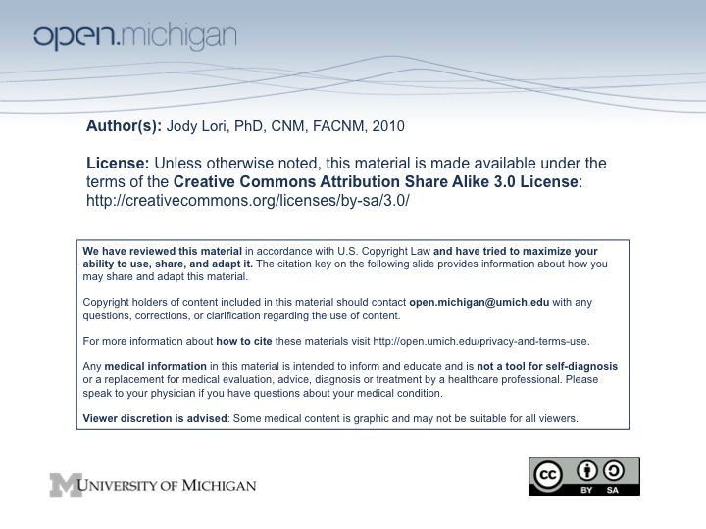

TOPICAL OUTLINE

N420/WS432

Fall, 2010

Week #1: (9/7/10)

Topic: Overview of the course

Health and Human Rights: An Overview

- Student expectations of the course
- Student expectations of the instructor
- Instructor’s expectations of herself
- Instructors expectations of the students
- The course syllabus
- Assignments
- Assigning group work
- Human Rights, a framework for global health

Readings and Activities:
- Read textbook, Chapter 1 and Appendix IV (pg. 331-335)
- Become familiar with the WHO publications on health and human rights http://www.who.int/hhr/en/
- Read Koplan et al, Toward a Common Definition of Global Health
- Read Fried et al, Global Health is Public Health
- Read Farmer et al, Education and Practice – Global Health Equity
- Read the report of the WHO Commission on the Social Determinants of Health led by Michael Marmot, WHO http://www.who.int/social_determinants/thecommission/finalreport/en/index.html

- Watch the following presentation on the web to stretch your imagination about global health and how you present information: http://www.ted.com/talks/hans_rosling_shows_the_best_stats_you_ve_ever_seen.html
- Watch this film clip on the Tuskegee Study: http://www.metacafe.com/watch/2170979/the_tuskegee_syphilis_experiment/

Week #2: (9/14/10)

Topic: Health Inequities

Film: What Are We Doing Here?

Readings and Activities:
- Read textbook Chapter 2

- Watch Paul Farmer 60 minutes http://www.cbsnews.com/video/watch/?id=4069409n
- Watch Displaced Families in DRC http://vids.myspace.com/index.cfm?fuseaction=vids.individual&videoid=11091979
- Watch Vaccinating the Public in the Midst of War – Afghanistan http://www.youtube.com/watch?v=WyjJkJq5kKo
- Watch In Myanmar, the disaster of surviving the disaster (UNICEF) http://www.youtube.com/watch?v=DacPJ4A_KrY&feature=related

Week #3: (9/21/10)

Topic: Millennium Development Goals and Burden of Disease

Readings and Activities:
- Become familiar with the Millennium Development Goals. Available at http://www.un.org/millenniumgoals/
- Read Accorsi, Countdown to 2015: comparing progress towards the achievement of the health MDGs in Ethiopia and other sub-Saharan Countries.
- Read Burki, UN women to spearhead new drive for gender equality
- Review The Global Burden of Disease & Risk Factors, Chapter 1 available at http://www.dcp2.org/pubs/GBD

- Watch the following presentation on the web: http://www.youtube.com/watch?v=elug11ocG3A
- Watch “The Seemingly Impossible is Possible”

http://www.gapminder.org/videos/ted-talks/hans-rosling-ted-talk-2007-seemingly-impossible-is-possible/

Week #4: (9/28/10)

Topic: Global health Challenges and Issues

Meet at Taubman Library in the foyer at 6:00pm for a 2 hour hands on session in the Resource Center with Gurpreet K. Rana, MLIS Coordinator, Library Global Initiatives and Global Health Liaison, on how to access global health databases and information.

Readings and Activities:
- Read textbook Chapter 3

Week #5: (10/5/10)

Topic: Maternal Health

MDG #5

Guest Speakers: Dr. Pamela Andreatta & Joey Perosky

Readings and Activities:
- Read Textbook, Chapter 4 (pg 70-89)
- Read Hogan et al, Maternal mortality for 181 countries, 1980-2008: a systematic analysis of progress toward MDG 5

- Watch My Sister, My Self from White Ribbon Alliance http://www.whiteribbonalliance.org/resources.cfm?a0=video&play=MYSISTERMYSELF
- Watch Maternal Mortality GapCast http://www.gapminder.org/videos/gapcasts/gapcast-7-maternal-mortality/
- Watch The Girl Effect http://www.girleffect.org/#/video/
- Watch Bangladesh – Hard Labor http://www.rockhopper.tv/programmes/354
- Watch Fight for Life – Afghanistan http://www.rockhopper.tv/programmes/43/

Week #6: (10/12/10)
Topic: Culture and Health
MDG #1

Readings and Activities:
- Read Textbook, Chapter 5
- Read Harrowing et al, Culture, context and community: ethical considerations for global nursing research

- Watch Professor Andrea Sankar Discusses Her Research on the Impact of Culture on Health http://www.youtube.com/watch?v=iDd58Iz0dPs
Watch Homophobia as a barrier to HIV testing: http://new.paho.org/hq/index.php?option=com_content&task=view&id=1368&Itemid=1

Paper 1 due

Week #7: (10/19/10)
No Class.

Readings and Activities:
- Textbook, Chapter 6

Week #8 (10/26/10)
Topic: Child Health
MDG#4
Guest Speaker: Cathy Bartos RN
- Read Textbook, Chapter 4 (pg 55-69)
- Read Rajaratnam et al, Neonatal, postnatal, childhood and under-5 mortality for 187 countries, 1970-2010: a systematic analysis of progress towards MDG 4
- Review USAID Global Health Learning Module, Immunization Essentials: http://www.globalhealthlearning.org/login.cfm

- Watch Poor Beat Rich in MDG Race http://www.gapminder.org/videos/poor-beats-rich/
- Watch Child Health Days in Zimbabwe http://www.youtube.com/watch?v=86n5pvYInHQ
- Watch Caring Talk Saves Lives http://www.youtube.com/watch?v=zxxz0spnq2s
- Watch Saving Newborn Lives: A Success Story in Malawi http://www.youtube.com/watch?v=u85hfdETG2A&feature=PlayList&p=CB282093BC9B1C79&index=0&playnext=1

Week #9 (11/2/10)
Topic: Infectious Diseases – HIV
MDG#6
Guest Speaker: Dr. Jon Cohn (7pm)

Readings and Activities:
- Read Textbook, Chapters 7
- Review the USAID Global Health Learning Modules, HIV Basics (Part 1) and Mother-to-Child Transmission of HIV: http://www.globalhealthlearning.org/login.cfm
- Read Horton & Das, Putting prevention at the forefront of HIV/AIDS
- Review the USAID Global Health Learning Module, Tuberculosis Basics and Tuberculosis Advanced Concepts: http://www.globalhealthlearning.org/login.cfm
- Explore the WHO site on TB http://www.who.int/tb/en/
- Explore the WHO home page on Malaria http://www.who.int/topics/malaria/en/
- Review the USAID Global Health Learning Module, Malaria: http://www.globalhealthlearning.org/login.cfm

- Watch AIDS in Thailand, Parts I&II & Fighting AIDS in Botswana http://www.pbs.org/wgbh/rxforsurvival/series/video/index.html
- Watch Love in a time of HIV – A Positive Match http://rockhopper.tv/aids2031/programmes.aspx?ProgrammeID=210
- Watch An Incurable TB? Parts I-IV http://www.pbs.org/wg0bh/rxforsurvival/series/video/index.html
- Watch UNICEF and Roll Back Malaria partnership deliver bednets to malaria-ravaged villages http://www.unicef.org/media/video_44531.html
- Watch Malaria’s Tenacious Grip http://www.pbs.org/wgbh/rxforsurvival/series/video/index.html
- Watch A World without AIDS http://www.youtube.com/watch?v=4jEcjZtUNks&feature=channel_page
- Watch The Search for a Vaccine http://www.youtube.com/watch?v=k73s0pmO3u8&feature=channel_page

Week #10 (11/9/10)
Nutrition
MDG#2
Guest Speaker: Dr. Betsy Lozoff

Readings and Activities:
- Textbook, Chapter 9
- Read the Overview (pg 1-19) of “Repositioning Nutrition as Central to Development” available at http://siteresources.worldbank.org/NUTRITION/Resources/281846-1131636806329/NutritionStrategy.pdf
- Read the policy brief from the Population Reference Bureau (PRB) on nutrition

- Watch UNICEF: Food Fortification in Africa http://www.unicef.org/videoaudio/video_3624.html
- Watch My future in my first centimeters (World Bank) http://youtube.com/watch?v=mJieb2Xgt9U
- Watch Feeding Children in Somalia with Plumpy’doz http://vids.myspace.com/index.cfm?fuseaction=vids.individual&VideoID=54233546
- Watch Nutrition for Niger (Plumpy’nut) http://www.youtube.com/watch?v=6VSCMoRDp2c

Paper 2 due

Week # 11 (11/16/10)
Wallenburg Medal Ceremony
Rackham Auditorium
Medal for Global Public Health
Dr. Mukwegu

Readings and Activities:
- Textbook Chapter 8
- Read Morens et al, The challenge of emerging and re-emerging infectious diseases
- Review Chapter 24 on Helminth Infections: soil transmitted helminth infections and schistosomiasis http://dcp2.org/pubs/DCP
- Read the policy brief from PRB on Neglected Tropical Diseases
- Read Musgrove & Hotez, Turning neglected tropical diseases into foreign maladies
- Read Hotez et al, Control of neglected tropical diseases

- Watch Preventing River Blindness, Parts I&II http://www.pbs.org/wgbh/rxforsurvival/series/video/index.html
- Watch Guinea Worm Disease in Africa http://www.youtube.com/watch?v=u4kQWvUv_Ns&feature=PlayList&p=46E90A82AE76CAD3&index=8

Paper 3 due

Week #12 (11/23/10)
Environmental Health
MDG #7
Guest Speaker: Dr. Elisha Rennes

Readings and Activities:
- Textbook, Chapter 10 & 11
- Review the USAID Global Health Learning Module, Population, Health, and Environment: http://www.globalhealthlearning.org/login.cfm

- Watch Population, Health and Environment http://www.youtube.com/watch?v=TGUtXzU-xb8
- Aceh ‘superhero’ promotes hygiene and sanitation http://www.unicef.org/media/video_42267.html
- Watch Awakening: Achieving Total Sanitation in Bangladesh http://www.youtube.com/watch?v=_YhwbePILZ0

Week #13 (11/30/10)
Global Health Priorities
MDG#3
A Walk to Beautiful - film

Readings and Activities:
- Read Textbook, Chapter 13
- Review the USAID Global Health Learning Modules, Female Genital Mutilation/Cutting: http://www.globalhealthlearning.org/login.cfm

- Watch UNICEF Female Genital Mutilation Report in Somalia http://vodpod.com/watch/206115-female-genital-mutilation-unicef-report
- Watch Obstetric Fistula in Rural Uganda http://www.engenderhealth.org/our-work/maternal/digital-stories-uganda-fistula.php

Week #14 (12/7/10)
Human Resources for Health/Workforce Issues
MDG #8
Guest Speaker: Amy Starke, RN, FNP

Readings and Activities:
- Read Textbook, Chapter 14
- Review the WHO Achieving the health-related MDGs. It takes a workforce! Link: http://www.who.int/hrh/workforce_mdgs/en/index.html
- Get an understanding of the density of doctors, nurses and midwives in the 49 priority countries Link: http://www.who.int/hrh/density_chart.pdf

- Watch Doctors without Borders http://www.youtube.com/watch?v=73zMcdGfXGE

Article Review due

Week #15
Scholarly paper due December 15, 2010 for those electing 3 credits

