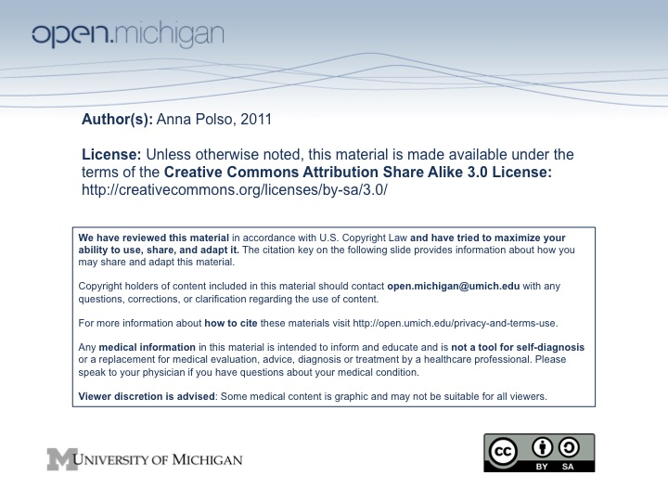

A comparison of median annual income and the use of multiple pharmacies in Michigan

Anna Polso
Pharmacy 476
April 19th, 2011

ABSTRACT
Objective: To determine if there is a correlation in adult consumers between the use of multiple pharmacies and median annual income.
Design: This study is an observational cross-sectional study.
Setting: The study will take place at three separate pharmacy types in Ann Arbor, MI: independent, chain, and grocery store. Two pharmacies will be selected randomly for each type.
Subjects: A total of 540 adult Michigan residents will participate in the study. Participants will be stratified by income level into two groups—either above or below Ann Arbor median income—upon receipt of their completed surveys to total 270 individuals in each distinct study group.
Intervention: Pharmacy customers will be approached during randomly selected one hour time periods by a trained research assistant and requested to participate in the study by completing an anonymous survey. Customers will be approached for the entire one hour allotted time period or until at least five completed surveys are obtained.
Measurements and Main Expected Results: Each survey will request age, gender, ethnicity, annual income, number of pharmacies used within the past year, number prescriptions for different medications filled within the past year, and main determinant of pharmacy choice. It is expected that the incidence of multiple pharmacy use is higher in individuals with income below the Ann Arbor median than those above.
Conclusions: Use of multiple pharmacies is already known to increase patient risk due to incomplete medication history resulting in inadequate safety determination of new prescriptions by filling pharmacists. If this study shows there is a significant association between income level and use of multiple pharmacies it will allow future research to examine the frequency of medication error or adverse events associated with multiple pharmacy use. This would stress the need for pharmacies to gather more patient information upon receipt of a prescription.
Keywords: patronage, community pharmacy, choice of pharmacy, patient preferences

INTRODUCTION AND BACKGROUND
The field of community pharmacy hinges on understanding the needs of the consumer. This knowledge not only allows the development of a successful business but also provides important insight on how to best provide a crucial health care service—safe and intelligent dispensing of medications. By studying the preferences, tendencies, and overall satisfaction of consumers regarding community pharmacies, pharmacy practices can be modified and improved upon.
One main area of focus in research has been patient patronage and influences on pharmacy selection. The 2001 National Pharmacy Consumer Survey gathered information from over one thousand adults on preferences and behaviors when utilizing a community pharmacy and reported convenience, price, and service as the top three determinants (1). The importance of a convenient location is not surprising, as it has long been implicated as a main factor in pharmacy patronage (2,3). The importance of cost was also reflected in a survey of elderly patients, which showed insurance coverage of prescription medications was a determining factor in pharmacy patronage (4).
Overall, there is an abundance of research and support as to why a patient may choose a particular pharmacy. However, a thorough examination of the use and trends behind use of multiple pharmacies to fill prescriptions is noticeably lacking despite the inherent risk associated with this practice. Using more than one pharmacy may result in incomplete medication information available to the filling pharmacist, increasing the possibility of medication related adverse events (5). Based on the importance of cost described above it is reasonable to expect that income may play a role in the use of more than one pharmacy due to coupons, pricing differences, and other promotions. Expanded knowledge on the prevalence of multiple pharmacy usage as well as identification of at risk populations for such practice may prompt a reevaluation of the information typically gathered by a pharmacy when filling a prescription for a patient.

HYPOTHESIS
The incidence of using more than one pharmacy is higher in adult consumers with an annual income below the Ann Arbor median income when compared to individuals with income above the median as reported in anonymous surveys taken at pharmacies of three different types in Ann Arbor, MI: independent, chain, and grocery store.

SPECIFIC AIMS
The hypothesis will be tested by the following specific aims:
- To determine the number of pharmacies adult consumers use through a short survey administered to patients at three types of pharmacies: independent, chain, and grocery store.
- To determine the main motivations behind use of multiple pharmacies in adult consumers through a short survey administered to patients at three types of pharmacies: independent, chain, and grocery store.
- To determine through an anonymous survey if there is a correlation between the use of multiple pharmacies by adult consumers and median household income.
- To establish additional information that could be gathered at a community pharmacy for first time as well as repeat customers in order to determine if medications have been obtained from other pharmacies.

STUDY DESIGN
The study is designed as an observational cross-sectional study. Participants in the study must meet the following criteria: age ≥ 25 years old, Michigan resident, makes their own decisions as to choice of pharmacy, and are personally responsible for payment of their prescription medications (this includes insured and uninsured, regardless of copayment amount). Independence in decision making is important in order to gain insight as to potential reasons for pharmacy choice. Excluded from participation include members of the following health care professions: physicians, physician assistants, nurses, and pharmacists. Health care professionals are typically more aware of safe medication practices and responsibilities of the pharmacist in dispensing which could skew results.
Study participation is voluntary and anonymous, and no financial incentives will be offered for completion of the survey. Surveys from participants will be evaluated as two distinct groups based on income level: those making above the Ann Arbor median annual income and those below. Participants will be stratified into their respective study group upon receipt of their completed survey. A total of 270 participants are needed in each study group (n=540) to provide adequate power to the results.
The study will take place at three separate pharmacy types in the Ann Arbor area: independent, chain, and grocery store. Two pharmacies will be randomly selected from a list of each type of pharmacy found within Ann Arbor city limits. Mail order pharmacies are excluded as customer surveys will be administered when picking up a filled prescription.
Data will be collected as done in a study by HJ Baldwin and colleagues (6). A one hour time slot will be selected at random, and each pharmacy will be sampled by assigning the time period on a rotating basis. This rotation will account for variation in customer flow throughout the work day. During the specified hour, a trained research assistant provided by the study will approach every person picking up a prescription to briefly describe the survey and request participation. The survey is to be completed at the pharmacy site and immediately returned to the research assistant. This will be repeated until the hour is up or the assistant receives five completed surveys from eligible participants. Sampling will continue in this manner until there are 270 survey results in each income-based group. The research assistant will be kept aware of the number of surveys obtained in each study group in order to determine when to conclude study recruitment.
The survey created specifically for this study will request the following information: age, gender, ethnicity, annual income (to determine study group assignment), number of pharmacies used within the past year, number of prescriptions for different medications filled within the past year, and the main determinant of pharmacy choice will also be requested for those indicating multiple pharmacy use. The primary endpoint will be the number of pharmacies used within the past year.

STATISTICAL PLAN
A total of 270 participants are needed in each study group (n=540) to provide a 90% confidence level with 5% margin of error in results. The survey will provide options for the participant to select gender, age, ethnicity, and main determinant of pharmacy choice, with an opportunity to write in an alternative answer for the latter. Participants will write in the number of pharmacies used within the past year, number of unique prescriptions received within the past year, and annual income.
The primary endpoint—number of pharmacies used—will give discrete ordinal data. The primary endpoint will be compared between the two study groups using the non-parametric Mann-Whitney U test. This test is the most appropriate as little can be assumed about the underlying populations’ distributions.
Responses from reason for pharmacy choice will produce nominal data. Each reason will be assigned a percentage based on frequency of selection. These values will provide insight as to main motivations for multiple pharmacy use but will not be statistically analyzed.
The remaining data gathered by the survey includes nominal (gender and race) and discrete numerical (age, number of prescriptions) data and will be examined using a contingency table. This will allow the identification of any confounding variables that may have impacted results regarding the primary endpoint.
All statistics will be performed by the Center for Statistical Consultation and Research at the University of Michigan. In all cases, a p-value ≤ 0.05 will be considered significant.

HUMAN SUBJECTS
Human subjects will be used in this study to examine the use of multiple pharmacies as it relates to income level. This will be done through the completion of a short, anonymous survey by each participant. As stated previously, inclusion criteria include: age ≥25 years old, Michigan resident, makes own decision for choice of pharmacy, and is personally responsible for payment of prescription medications (including insured and uninsured). Excluded are health care professionals as described previously.
Study eligibility will be determined upon initial contact with the research assistant at the study site. Recruitment will occur as described previously by approaching every customer picking up a prescription during the pharmacy’s assigned time slot or until five eligible surveys are completed. This will be repeated until the required number of surveys is collected for each study group. Permission to conduct the study at the pharmacy will be obtained before proceeding with the study at the site. No IRB review, Data Safety Monitoring Board, or informed consent will be required for this study. The research assistant will briefly describe the basis of the survey to the participant, and this information will also be available to the subject in the form of a short cover letter provided with the survey. The cover letter will also ask if the individual is a health care professional, as dictated in the exclusion criteria, in order to filter out inappropriate study participants. The participant may decline participation in the survey.
The only expected risk to the participant pertains to data confidentiality. This risk will be minimized by collecting non-identifying data and administering surveys in a separate counseling room or otherwise isolated area at the study site. Additionally, surveys will be immediately enclosed in an envelope upon return to the research assistant. The research assistant will be responsible for keeping returned surveys secure at the study site and promptly returning them to the lead investigator, where all results will be stored in a locked file cabinet.
A total of 540 subjects will participate in this study, with half making less than the median annual income of Ann Arbor and the other half making more than the median. According to 2005 to 2009 demographic information of Ann Arbor obtained from the U.S. Census Bureau, the study population is expected to have an approximately equal number of men and women and show the following racial distribution: 74% white, 7% African American, 14% Asian, and 5% other. Also note that no children or other vulnerable populations will take part in this study.

CONCLUSIONS, LIMITATIONS, AND FUTURE DIRECTIONS
Although use of multiple pharmacies has been reported in previous studies, no studies have looked at possible trends or reasons for such practice based on patient characteristics. This study expects to show the incidence of using more than one pharmacy to be higher in adult consumers with annual incomes below the Ann Arbor median income when compared to individuals with incomes above the median.
Possible limitations to this study include participant honesty and recollection. Although it will be made clear to the participant that all results will remain anonymous, honesty in reporting annual salary as well as other answers may still be an issue. Additionally, even when given ample time to complete the survey it may be difficult for participants to accurately recall information regarding pharmacy use over the past year.
If the hypothesis is proven true, future research should examine the incidence of medication errors and adverse events occurring in community pharmacies that could have been prevented if knowledge of prescriptions filled at other pharmacies was known by the filling pharmacist. This would demonstrate the need for the pharmacy to gather more patient information upon receipt of a prescription and potentially lead to both a change in pharmacy store policies and improved patient safety.

REFERENCES
- Stergachis A, Maine LL, Brown L. The 2001 National Pharmacy Consumer Survey. J Am Pharm Assoc (Wash) 2002 Jul-Aug;42(4):568-576.
- Gagnon JP. Factors affecting pharmacy patronage motives--a literature review. J Am Pharm Assoc 1977 Sep;17(9):556-9, 566.
- Herman CM, Wills RA,Jr. A demographic analysis--community pharmacy patronage. J Am Pharm Assoc 1974 Feb;14(2):66-70 passim.
- Xu KT. Choice of and overall satisfaction with pharmacies among a community-dwelling elderly population. Med Care 2002 Dec;40(12):1283-1293.
- Polinski JM, Schneeweiss S, Levin R, Shrank WH. Completeness of retail pharmacy claims data: implications for pharmacoepidemiologic studies and pharmacy practice in elderly patients. Clin Ther 2009 Sep;31(9):2048-2059.
- Baldwin HJ, Riley DA, Wojcik AF. Prescription purchasers' patronage motives. Pharm Manage Comb Am J Pharm 1979 Jul-Aug;151(4):185-190.

