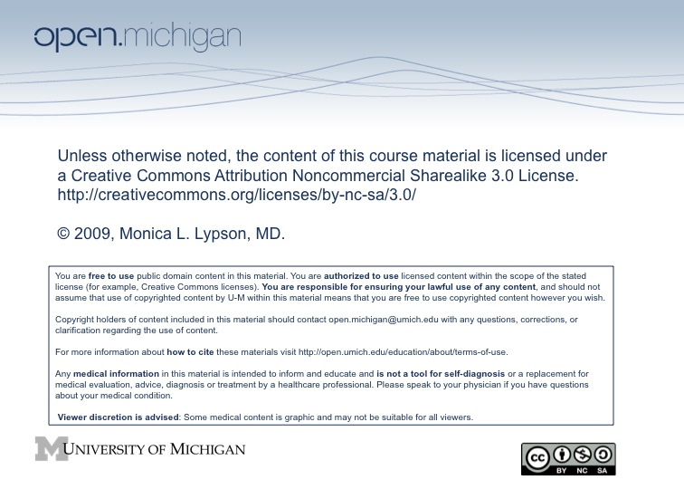

Ms. Vlas Case Evaluation

Faculty Moderator Name: ________________

Please rate your level of agreement with the following statements:
 | Strongly  Disagree  1 | Disagree  2 | Neutral  3 | Agree  4 | Strongly  Agree  5
1. The goals of the case were clear.
2. The case was effective in helping me think about the importance of Ms. Vlas’s social history.
3. The moderator actively involved the group in teaching and learning.
4. The exercises improved my ability to critically and thoughtfully approach the subject matter.
5. The moderator was open to different viewpoints and helped everyone to speak.
6. The handouts and resources were useful.
7. I have a basic understanding of taking a social history and its usefulness in the medical interview.
8. The case was an effective learning experience.

Comments on the case and group activities:

Suggestions for Improvement:

